**ROOM 1**

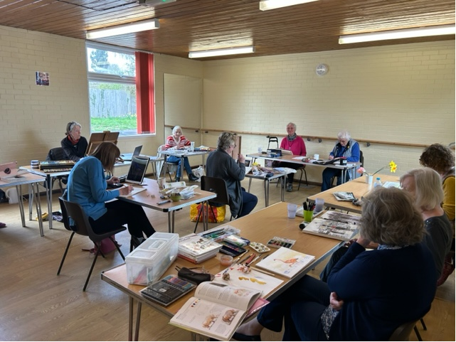

**DIMENSIONS**

6m x 7m (45 sqm)

**FACILITIES**

* Small sink/hand washing area
* Hard floor
* Tables and chairs available
* Ideal for social and creative groups and small parties
* This room is available from £9.50 per hour for regular users. Preferential rates available for one off bookings for Great Cornard residents