THE HALL

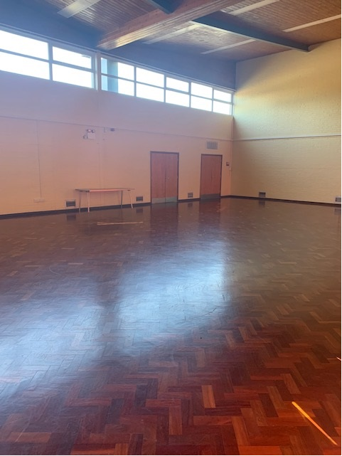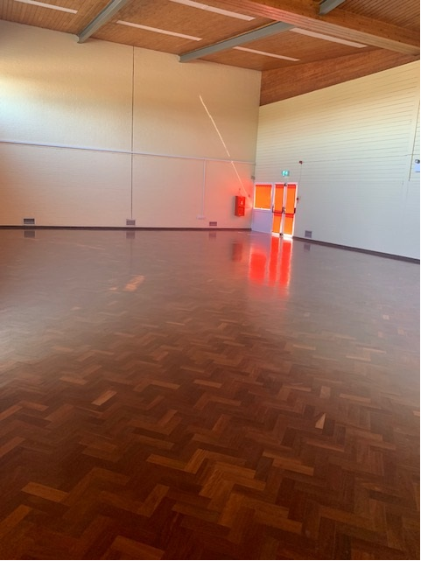

DIMENSIONS
10m x 16m (160 sqm)

FACILITIES
- Very large open space with two sets of fire doors that lead out onto the Recreation Ground and childrens play area
- Tables and chairs available
- Ideal for large parties and events, sports and exercise classes
- This room is available from £15 per hour for regular users. A preferential rate is available for one off bookings for Great Cornard residents

