THE KITCHEN
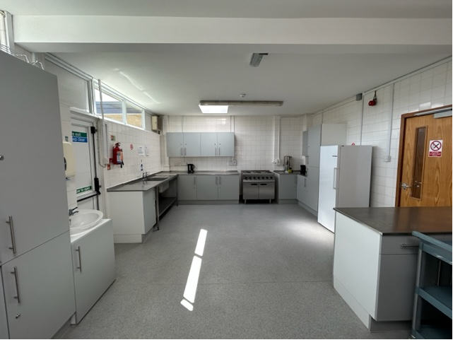
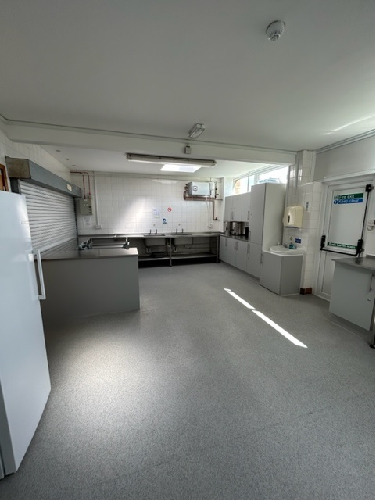
DIMENSIONS
32.9 Sqm

FACILITIES
- Large professional kitchen
- Fire door and Fire Exit onto Recreation Ground
- Fire extinguisher and blanket
- Double oven and hob
- 3 large sinks and separate handwashing area
- Large larder style refrigerator
- Automatic rolling shutter to serving hatch
- Serving trolleys available
- Use of kitchen included in room hire charge

