

**GREAT CORNARD PARISH COUNCIL**

Minutes of the Meeting of the **POLICY & RESOURCES COMMITTEE**

held in The Stevenson Centre at 7:43pm on Monday 24th October 2022

**PRESENT** Councillors A C Bavington **Chairman**

Mrs S Bowman K Graham T J Keane M D Newman

S M Sheridan T M Welsh

Mrs P White Mrs J Wilson

C G Wright

Council Manager Mrs N Tamlyn

Council Administrator Miss E Skuce

1. **APOLOGIES FOR ABSENCE**

**NONE.**

1. **DECLARATIONS OF INTEREST AND REQUESTS FOR DISPENSATIONS**

Councillor Bavington declared a non-pecuniary interest in any item relating to Thomas Gainsborough School as he volunteers at the School and a family member is employed by the Trust.

Councillor Welsh declared a non-pecuniary interest in any item relating to the Village Hall as a family member is a member of the Scouts.

1. **DECLARATIONS OF GIFTS AND HOSPITALITY**

**NONE.**

1. **ITEMS BROUGHT FORWARD – FOR NOTING**

Members reviewed and **NOTED** the Items Brought Forward list.

1. **CORRESPONDENCE**

**a) Babergh District Council: Town & Parish Council Election 2023 Cost Estimate**

Members reviewed and **NOTED** correspondence from Babergh District Council which provided an estimate of election costs for Great Cornard for 2023.

|  |  |  |  |
| --- | --- | --- | --- |
|  | **Uncontested** | **Contested** | **Contested Combined with District Election** |
| **Great Cornard North** | £182.58 | £4,536.57 | £3,948.78 |
| **Great Cornard South** | £187.11 | £4,403.28 | £3,902.29 |

The Chairman stated that there were already funds set aside for elections and the Council Manager confirmed that this year’s by-election had not yet been invoiced and the cost was not yet known. **NOTED**.

**b) Babergh District Council: Joint Local Plan – Update**

Members reviewed and **NOTED** the update received from Babergh District Council regarding the Joint Local Plan, which indicated that the adoption of the Plan had been delayed and that public consultation was not likely to happen until late Autumn.

**c) West Suffolk Council: Winter Response Fund**

Members reviewed correspondence from West Suffolk District Council which informed of grants available for community groups and organisations to help towards the cost of providing support that will help local residents stay connected, stay warm and provide other support and activities during the winter months.

The Council Manager advised that Babergh District Council had now circulated papers for their own winter warmth support fund which had a closing date of 31st October 2022 at 5pm.

As the Parish Council does not normally provide such services, it was **AGREED** that it would be better to ensure that all relevant local groups and organisations were made aware of the Fund. The Council Manager advised that the information had already been sent to various local groups including St Andrew’s Church and would also be passed to schools and the Still Good to Eat Community Shop.

1. **FINANCIAL MATTERS**
2. **To approve the latest list of payments**

Members reviewed and **NOTED** the latest list of payments. **(see Appendix A).**

1. **Parish Council Neighbourhood CIL payment – October 2022**

Members **NOTED** that a sum of £2,745.65 had been received from Babergh District Council in relation to Community Infrastructure Levy payments for the period of 1st April 2022 to 30th September 2022.

The correspondence also states that if a Parish Infrastructure Investment Plan (PIIP) has been produced then it should be forwarded to the District Council. The Chairman advised that the Parish Council’s PIIP was due to be reviewed again and would be considered at the next Policy and Resources Committee meeting. **NOTED.**

1. **To consider the latest Financial Management Report**

Members reviewed and **NOTED** the Financial Management Report up to 24th October 2022. **(See Appendix B).**

1. **To consider the FY2021/22 Virement Report**

Members reviewed and **NOTED** the report on the Virement of Unallocated General Reserves for FY 2021/22. **(See Appendix C).**

The Chairman stated that the introduction of a Major Projects List which allocated high, medium and low priority status to planned projects had allowed the Council to build funds for projects such as the Village Hall extension.

Members agreed to **RECOMMEND** to Full Council to accept the findings of the Report and to vire the following figures:-

**FY21/22 Unallocated General Reserves**

1. To vire the FY21-22 Unallocated General Reserves of £33,128.07 to be vired to the Village Hall Improvement Fund to cover the cost of design and legal fees and works to the Right of Way and continue to build funds for the Village Hall Extension Project. It was agreed that £4,250 would be earmarked for legal fees.

**Earmarked Funds from completed projects**

1. Remaining Village Gateway Fund of £1,021.77 to be vired to the Commemorative Bench Fund.
2. Remaining Queen’s Platinum Jubilee Fund of £1,283.64 to be vired to the Recreation Ground Improvement Fund for new picnic tables and benches.

**Other Earmarked Funds**

1. To remove The Stevenson Centre foul drains project and vire £5,000 to the SC car park surface water drainage scheme.
2. Neighbourhood Plan Fund of £5,000 to be vired to the Village Hall Improvement Fund on the understanding it can be reinstated in the future.

**Allocation of Neighbourhood CIL Fund**

1. To allocate £22,220.15 to improving the security on Parish Council owned land and any remaining funds to be allocated to the Street Light Fund, so further works to Phase 1 of the Street Light Improvement Project can be instructed.

**The Stevenson Centre Budget Virement**

1. The Stevenson Centre Grant Budget of £6,378 to be vired to the Salaries and Wages Budget in order to cover any potential overspend on salaries.
2. **Proposal to EXCLUDE PRESS AND PUBLIC from the meeting in accordance with section 1 of the Public Bodies (Admission to Meetings) Act (1960) for the following items of business on the grounds that they involve the likely disclosure of confidential and exempt information**

The Chairman proposed that the Press and Public be excluded from the meeting in accordance with Section 1 of the Public Bodies (Admission to Meetings) Act (1960) for the following items of business on the grounds that they involve the likely disclosure of confidential and exempt information. **AGREED.**

1. **To receive the Project Brief and Budget Evaluation for the Village Hall Extension Project**

Members reviewed and **NOTED** a Project Brief and Fee Statement from Concertus in relation to the extension works required at the Village Hall. The Chair advised that the Fee Statement of £2,620 to provide a feasibility study associated with the rear extension at the Village Hall had already been approved by the Council.

The Chairman outlined the estimated costs in the Project Brief, which were based on a cost per sqm and indicated that phase one was estimated at a lower cost than phase two. The Chairman stated that if Full Council approved the virement of funds as per Item 6 iv) of this Agenda, then the allocated funds for the Village Hall extension would be close to the estimated cost for phase one. There was also scope to apply for grants and possibly a PWLB loan to ensure the completion of both phases.

Members agreed to **RECOMMEND** to Full Council to accept the contents of the Project Brief and its estimated costings and continue to build funds for the project.

Members discussed renewing the Scout’s Lease as a matter of urgency and the Council’s current problem of receiving legal advice in a timely manner. It was **AGREED** for the Council Manager to look into the provision of legal advice from alternative legal firms due to the need to complete the Lease by the next election.

Members also **AGREED** to seek legal advice on the possibility of extending the availability of the building to other community groups during the day. It was noted that letting to other groups may assist any applications for funding.

1. **Suffolk Pension Fund: Funding Strategy Statement September 2022**

Members reviewed and **NOTED** the Funding Strategy Statement for September 2022 which included the Suffolk Pension Fund 2022 Actuarial Valuation.

It was also **NOTED** that the Fund was in a positive funding position and the majority of employers would benefit from a reduction in their contribution rates for the next three years.

A Member stated that it was the best valuation that they had seen in thirty years.

The Chairman took this opportunity to advise Members that Babergh District Council had published their draft recommendations in relation to the Community Governance Review and recommended no changes for Great Cornard.

It was noted that there was no mention of Great Cornard Parish Council’s submission in the draft recommendations and it was **AGREED** for the Council Manager to contact the District Council and ask why there was no reference to the Parish Council’s response.

**Meeting closed at 8:33pm**

**APPENDIX A**

**GCPC Summary of Income and Expenditure up to 24th October 2022**

|  |  |  |  |
| --- | --- | --- | --- |
| **INCOME UPTO** |  |  |  |
| **24.10.22** | **Source** | **Amount** | **Details** |
|  | Cemetery | £28.00 |  |
|  | Allotments | £25.00 |  |
|  |  |  |  |
|  |  |  |  |
|  |  |  |  |
|  |  |  |  |
|  | TOTAL | **£53.00** |  |
| **EXPENDITURE** | |  |  |
| **Direct Debits** | **Company** | **Amount** | **Details** |
|  |  |  |  |
|  |  |  |  |
|  |  |  |  |
|  |  |  |  |
| **BACS** | **Company** |  | **Details** |
|  | Salaries | £4,354.87 |  |
|  | HMRC | £1,208.13 | Pension Payover |
|  | SCC Pension Fund | £1,590.30 | NI & Tax Payover |
|  | Concertus | £2,448.00 | VH Fees incld. RIBA Stage 1 & 2 |
|  | Sudbury Town Council | £2,114.80 | 1st Qrtr Community Warden Services |
|  | Sudbury Town Council | £1,967.68 | 2nd Qrtr Community Warden Services |
|  | Sudbury Garden Services | £450.00 | Grnds Maint. Cntrct - St Andrews Church |
|  | Sudbury Garden Services | £760.00 | Grnds Maint. Cntrct - St Andrews Church |
|  | Mrs N C Tamlyn | £12.00 | Reimburse cost of Land Searches - V Green |
|  | S.P Landscapes & Tree Contracts Ltd | £18,540.00 | Ground works to Village Hall RoW* |
|  | S.P Landscapes & Tree Contracts Ltd | £1,110.00 | Removal of Stones on Village Hall RoW** |
|  | Ricoh UK Ltd | £548.35 | Qrtrly Photocopier Contract & Usage |
|  |  |  |  |
|  |  |  |  |
|  |  |  |  |
|  | **TOTAL** | **£35,104.10** |  |
| * | **£4K to be reimbursed re. Terms of Easement** |  |  |
| ** | Reimbursed by resident |  |  |

**APPENDIX B**



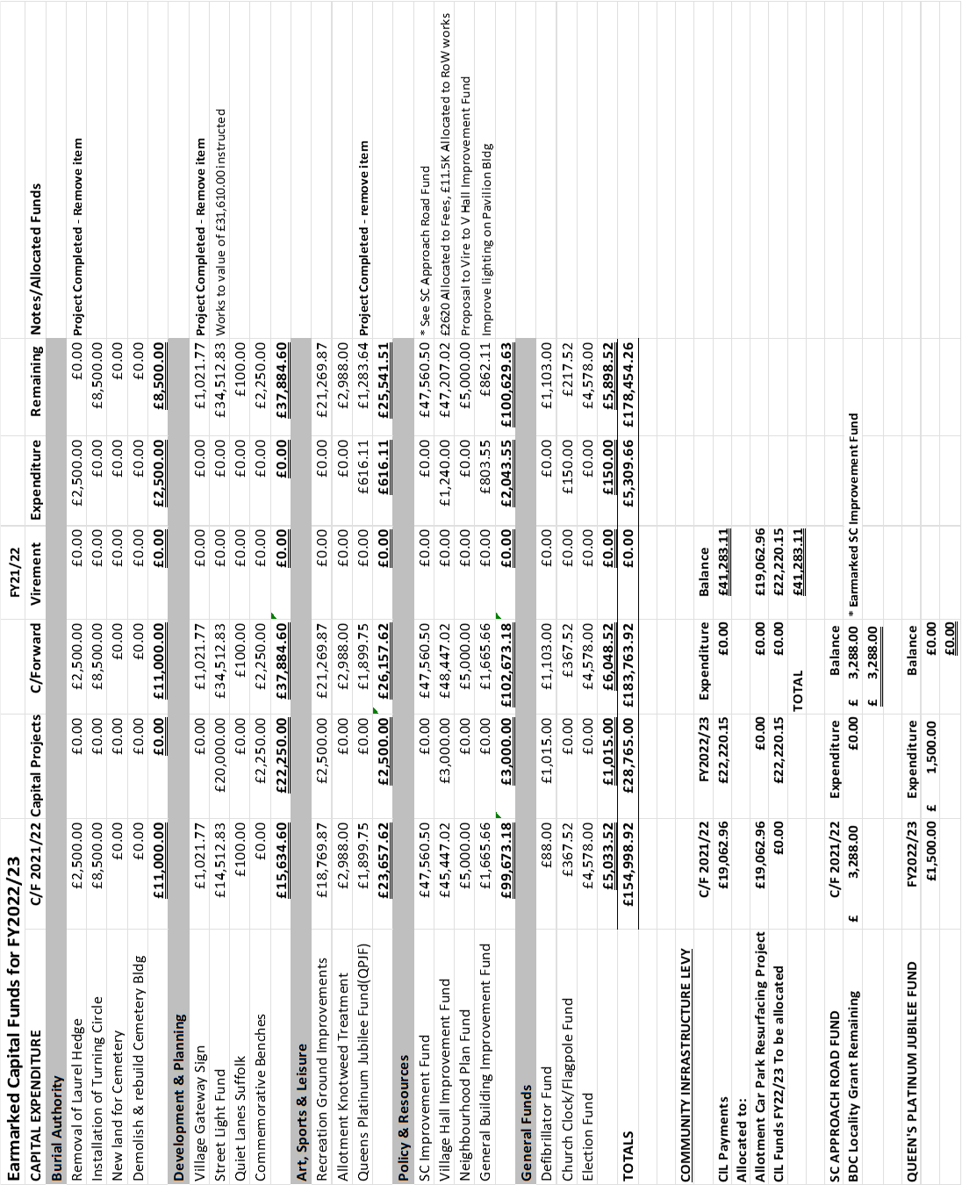

**APPENDIX C**

**Report on the proposed Virement of FY21/22 Unallocated General Reserves and**

**remaining Earmarked Funds from completed Projects**

To consider the virement of unallocated General Reserves for FY21/22 of **£33,128.07** and any remaining Earmarked Funds from projects which have been completed.

Please see attached the latest Finance Management Report up to 17th October 2022.

**Burial Authority £8,500:**

1. **High** - Removal of Laurel hedge – **Project completed**.
2. **High** - Turning Area £8,500 – To continue to build funds for this project.
3. **Additional Funds to be considered in the FY23/24 Budget**
4. **Medium** - Acquisition of land for a new Cemetery
5. **Low** - Cemetery Building – Proposal to demolish and rebuild with improved facilities

**Development and Planning Committee £37,884.60:**

1. **High** - Village Gateway Sign £1,021.77 – **Project completed**. Remaining funds to be vired.
2. **High** – Street Light Fund - £34,512.83 – Works to the value of £31,610.00 instructed. Balance of £2,902.83 to be used as contingency for emergency works. To continue to build funds via the FY23/24 Budget and Neighbourhood CIL (**See below CIL Report**)
3. **High** - Quiet Lanes Suffolk £100 - SCC to fund majority of cost – GCPC agreed to contribute £100.
4. **Medium** – Commemorative Bench Fund £2,250.00 - To install new benches throughout the village to commemorate the Queen’s Platinum Jubilee. Estimated cost for a wrought iron bench £750/Recycled plastic £500.

**RECOMMENDATION:**

1. **To vire remaining Village Gateway Fund of £1,021.77 to the Commemorative Bench Fund**

**Arts, Sports & Leisure Committee £25,541.51**

1. **Medium** - Recreation Ground Improvement Fund £21,269.87 – Project to improve play area facilities on the Recreation Ground. PC to apply for S106 Recreation Funds of up to £50k. If secured, the project will be raised to a high priority.
2. Allotment Knotweed Treatment £2,988 - No additional Funds required.
3. Queen’s Platinum Jubilee Fund £1,283.64 – **Project Completed.** Remaining funds to be vired.

**RECOMMENDATION:**

1. **To vire the remaining QPJF of £1,283.64 to the Recreation Ground Improvement Fund for new picnic tables and benches.**

**Policy and Resources Committee £100,629.63**

**Stevenson Centre Improvement Fund of £47,560.50 includes:**

1a). **High** – SC Foul Drains £5,000 – The SC Charity have agreed to fund the project and £5,000 can now be vired to the surface water drainage scheme instead.

1b). **High** – SC Car Park Surface Water Drainage Scheme and resurfacing currently £42,560.50 – Estimated cost in 2020 £57k

1. **High -** Village Hall Improvement Fund £47,207.02 **-** Costs agreed so far:

* £2,620 Fees to draw up plans for Village Hall extension;
* Approximately £11,500 for works to the Right of Way.

The project is likely to be carried out in two phases and in order to build funds to finance the project, it is proposed to vire the majority of the FY21/22 Unallocated General Reserves to the Village Hall Improvement Fund. The Council will also need to assemble further funds from grants, a PWLB Loan and the FY23/24 Budget.

**Village Hall Legal Fees**

The Village Hall legal matter is still ongoing and the Council has yet to be charged any legal fees. In order to prepare for the possibility of a large legal bill, it is proposed that **£4,250** from the FY21-22 unallocated General Reserves be vired to cover legal fees under the Village Hall Fund Improvement heading.

1. **Medium** - Neighbourhood Plan (NP) Fund £5,000 – On hold until BDC Joint Local Plan (JLP) approved. Due to the District Council’s lack of progress with the JLP, it is unlikely that the NP funds will be needed in the next FY. It is therefore suggested that the £5,000 NP Fund be vired to the Village Hall Improvement Project, as a short term achievable project, subject to the NP fund being reinstated once the JLP has been adopted.
2. **General Improvement Funds** £862.11 – Remaining Pavilion Improvement Funds allocated to improving the lighting in the Blackhouse Lane car park.

**RECOMMENDATIONS:**

1. **To remove the SC foul drain project and vire £5,000 to the SC car park surface water drainage scheme.**
2. **To vire the whole FY21-22 Unallocated General Reserves of £33,128.07 to the Village Hall Improvement Fund to cover the cost of design and legal fees and works to the Right of Way and to continue to build funds for the Village Hall Extension Project**
3. **To vire the £5,000 Neighbourhood Plan Fund to the Village Hall Improvement Fund on the understanding it can be reinstated in the future.**

**General Funds**

1. Defibrillator Fund £1,103.00 – Allocated to new defibrillator at Applegate Mews and to cover the cost of consumables. Further funds to be considered in FY23/24 Budget.
2. St.Andrew’s Church Clock/Flagpole £367.52:
3. Flag Pole - Project completed.
4. Church Clock - To build funds for future repairs/maintenance to the clock.

Additional funds to be considered in FY23/24 Budget.

1. Election Fund £4,578.00 - To continue to build Election funds via the FY23/24 Budget.

**Summary of Virement of FY21-22 Unallocated General Reserves**

|  |  |  |  |
| --- | --- | --- | --- |
|  |  | **FY21-22 Unalloc. General Reserves** | **TOTAL** |
| **Village Hall Improvement Fund** | **£47,207.02** | **£33,128.07** | **£80,335.09\*** |

**\*£4,250.00 earmarked for legal fees**

**Summary of outstanding Earmarked Funds from completed projects**

|  |  |  |  |
| --- | --- | --- | --- |
|  |  | **Vired Funds** | **Total** |
| **Commemorative Bench Fund** | **£2,250.00** | **£1,021.77** | **£3,271.77** |
| **Recreation Improvement Fund** | **£21,269.87** | **£1,283.64** | **£22,553.51** |

**Proposed allocation of the FY22/23 Neighbourhood Community Infrastructure Levy:**



Following the recent traveller incursion, the Parish Council has agreed to improve its security on Parish Council owned land. The Great Cornard District Councillors have agreed to allocate their FY22/23 Locality Budget of £6,000 to the project, but the cost of the works is currently unknown.

Once the costs are established it is **RECOMMENDED** that anything over £6,000 is allocated from the FY22/23 CIL Neighbourhood Fund and the remaining sum be allocated to the Street Light Fund, so further works to Phase 1 of the Street Light Improvement Project can be instructed.

**Proposed virement of The Stevenson Centre Grant Budget of £6,378 to the Salaries and Wages Budget**

The National Joint Council pay increase has not been agreed yet but it is likely to be considerably more than budgeted. As the SC is performing well and is unlikely to require the Parish Council’s support grant this Financial Year, it is **RECOMMENDED** that the SC Grant Budget of £6,378 be vired to the Salaries and Wages Budget in order to cover any potential overspend on salaries.