

**GREAT CORNARD PARISH COUNCIL**

Minutes of the Meeting of the **POLICY & RESOURCES COMMITTEE**

held in The Stevenson Centre at 7:24pm on Monday 24th April 2023

**Present**  Councillors A C Bavington **Chairman**

Mrs S Bowman T J Keane

M D Newman S M Sheridan

Mrs P White C G Wright

Council Manager Mrs N Tamlyn

Council Administrator Miss E Skuce

1. **APOLOGIES FOR ABSENCE**

Apologies were received from Councillors Mrs J Wilson, K Graham and T M Welsh.

The Chairman thanked Committee Members for their efforts during this current term and especially to those Members not returning in May.

1. **DECLARATIONS OF INTEREST AND REQUESTS FOR DISPENSATIONS**

Councillor Bavington declared a non-pecuniary interest in any item relating to Thomas Gainsborough School as he volunteers at the School and a family member is employed by the Trust.

1. **DECLARATIONS OF GIFTS AND HOSPITALITY**

**NONE.**

1. **ITEMS BROUGHT FORWARD – FOR NOTING**

Members reviewed and **NOTED** the Items Brought Forward list.

1. **TO RECEIVE AN UPDATE ON THE JOINT LOCAL PLAN MODIFICATION**

Following a meeting of this Committee in March, the Council Manager had been asked to clarify whether the reference to the designation of open spaces being removed deleting Policy LP30 (Designated Open Spaces), in the Modification Consultation Explanatory Notes, affected the Council’s plans to have the Great Cornard Country park designated once the JLP had been adopted. The Council Manager had provided Members with the relevant section of the document but the Chair felt that there was still no mention of the Country Park and wanted to ensure that when the JLP was adopted, the Country Park had sufficient protection.

It was **AGREED** for the Council Manager to contact Planning Policy at Babergh District Council and clarify the matter.

1. **TO RECEIVE AN UPDATE ON THE NEW AND REFURBISHED VILLAGE HALL SIGNS**

Members reviewed photographs of the newly installed and refurbished signs at the Village Hall **(see Appendix A)**. Members were pleased with both signs and felt the contractor had done a good job. It was **AGREED** to remove the item from the Brought Forward List.

1. **TO RECEIVE AN UPDATE ON THE VILLAGE HALL PLANNING APPLICATION**

The Chairman informed Members that following the Parish Council’s submission of revised plans to reduce the pitch height, full planning permission had been granted by Babergh District Council. The Chairman stated that the development would need to begin within three years of the date of the Planning Permission (31st January 2026) and that the new Council would need to assemble funds in FY2023/24 and FY2024/25 in order to prepare for a possible start date in FY2025/26. **NOTED.**

The Chairman stated that Members should be pleased with achieving the Committee’s goal of obtaining planning permission for the project before the end of this current term.

1. **TO REVIEW THE FOLLOWING PARISH COUNCIL POLICIES**
2. **Procurement Policy**

Members reviewed Report No. F18 **(see Appendix B)** and were reminded that at the last meeting of this Committee, the Council Manager was tasked with checking the Council’s Procurement Policy to see whether it contained the provision for post installation inspections on Parish Council led projects. The Council Manager confirmed that she had checked the Policy and that it did not contain the relevant provision and the proposed amendments contained in the Report would address this.

A Member suggested that it could be restrictive to only have the Council Chairman and/or Chairman of the relevant Committee carrying out the initial post installation inspection. It was stated that assembling lots of people, for example the relevant working party, to attend a post installation inspection may delay matters and a speedy inspection would be required to address any issues as early as possible.

In relation to the second proposed amendment detailed in the Report, the Council Manager explained that the procurement thresholds in the Public Contracts Regulations 2015 had increased from £25,000 to £30,000 from 21st December 2022. The thresholds for contracts valued over £189,330 for a public supply or public service contract, or £4,733,252 for a public works contract had also changed to £213,477 and £5,336.937 respectively. **NOTED.**

Members agreed to **RECOMMEND** to Full Council that it accepts the proposed amendments contained in Report No. F18.

1. **Environmental Policy Statement**

The Chairman stated that the review of this Policy was to be withdrawn from the Agenda as it required some further work and that it would be presented at a future meeting. **NOTED.**

1. **FINANCIAL MATTERS**
2. **To approve the latest list of payments**

Members reviewed and **NOTED** the latest list of payments **(see Appendix C)**

The Council Manager confirmed that the payment to STC Solutions was for the new CCTV camera that points down the approach road. The camera had been proposed by the Security Improvements Working Party as part of the project to improve security on the Recreation Ground following the 2022 traveller incursion. The Council Manager invited Members to visit the office to see the view of the approach road provided by the new camera. **NOTED.**

A Member enquired about the payment to the National Allotment Society and the Council Manager confirmed that it was a very useful service that had provided the Council with advice on matters such as pest control and weed control. **NOTED.**

The Council Manager confirmed that Thomas Gainsborough School had submitted the invoice for the Swimming Pool grant in time for the end of the financial year. **NOTED.**

**Meeting closed at 7:49pm**

**APPENDIX A**

**New Village Hall Signs**

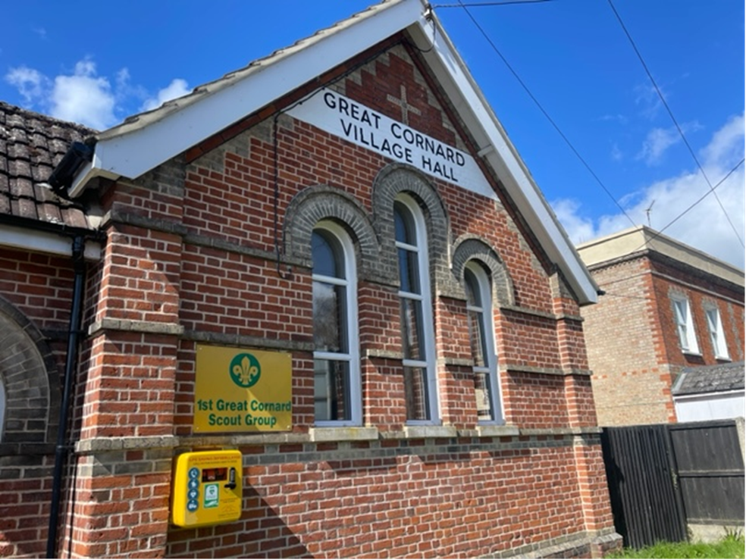

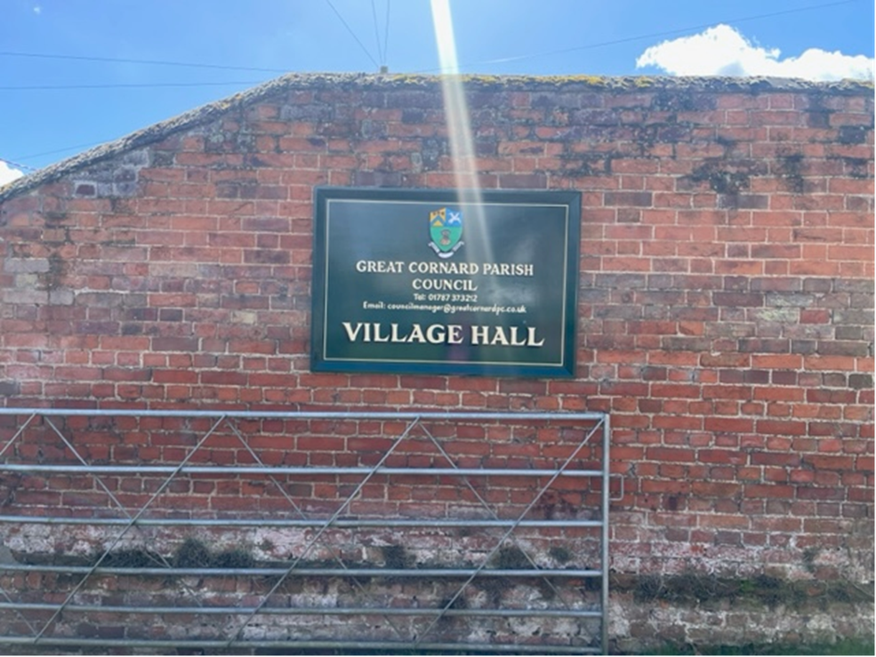

**APPENDIX B**

**Report No. F18**

**Proposed amendment to the Procurement Policy**

In response to the Policy and Resources Committee request, the Council Manager has reviewed the Procurement Policy to check whether it includes provision for post installation inspections.

Although Page 3, Item 18. states that “the Council Manager shall obtain the necessary technical assistance to prepare a Specification for approval by the Council”, there is no specific provision for a post installation inspection.

In the case of the recent project to resurface the Allotment Car Park, the Parish Council relied on the experience and guidance of contractors to draw up the Specification and it would not have been practical to bring in a ‘specialist’ at the final stage of the project. However, with the Council’s current plans to refurbish the Recreation Ground, there is a legal requirement for post installation inspections to be carried out.

As part of the Specification process, it is suggested that a new item be added to state that the Parish Council shall give consideration to the need for an independent post installation inspection, once the works are completed and for the cost to be born by the contractor.

It is also proposed that a new item for Post Installation/Works Inspection be added, which should state that:-

Following notification by the contractor that all the works detailed in the contract Specification have been carried out, the Council Manager shall first inspect the site along with the Council Chairman and/or the Chairman of the appropriate Committee and report back to the Council on the outcome of their inspections. If prior to awarding the contract, the Council agreed to instruct a post installation inspection, the Council Manager shall instruct the services of an inspector/surveyor to assess that the works have been completed in line with the Specification and to an appropriate standard, prior to any invoice being presented to the Council.

If there is a specific legal requirement to carry out a post installation inspection (such as a play area installation), the Council Manager will ensure that the appropriate Inspection Certificate is received, prior to any invoice being presented to the Council.

**Proposed additional amendments in line with changes to the Public Contracts Regulation 2015**

**Procurement Thresholds**

The Procurement Thresholds in the Public Contracts Regulations 2015 have increased from £25,000 to £30,000 from 21st December 2022.

Public contracts, with an estimated value (including VAT, from 1st January 2023):

Over £213,477 (previously £189,330 ex VAT) for goods and services, or

Over £5,336,937 (previously £4,733,252 ex VAT) for public works (construction),

Must comply with the full requirements of the Public Contracts Regulations 2015. These include specific tendering methods and timescales, as well as a requirement to advertise on the Contracts Finder website and Find-a-Tender (the UK e-notification service). Where a contract will run for several years, it is the total (not annual) value that matters.

**APPENDIX C**

**Summary of Income and Expenditure for Great Cornard Parish Council up to 24th April 2023**

