

**GREAT CORNARD PARISH COUNCIL**

Minutes of the Meeting of **GREAT CORNARD PARISH COUNCIL**

held at The Stevenson Centre at 7:06pm on Monday 12th June 2023

**PRESENT** Councillors Cllr Tom Keane **Chairman**

Cllr Marjorie Bark Cllr Tony Bavington Cllr Sharon Bowman Cllr Jane Brooker

Cllr Melanie Keane Cllr Stewart Sheridan Cllr Pamela White Cllr Judith Wilson

Cllr Colin Wright Cllr David Young

District Cllr Ruth Hendry

Council Manager Mrs N Tamlyn

Council Administrator Miss E Skuce

1. **APOLOGIES FOR ABSENCE**

Apologies were received from Cllrs Kevin Graham and Jane Wakeman.

1. **CHAIRMAN’S ADDRESS**

The Chairman advised Members that he had received an invitation to an exhibition at Mill Tye Gallery and extended the invitation to any other Member that may wish to accompany him.

Cllr Judith Wilson explained that she would need to leave the meeting at approximately 7:45pm. **NOTED.**

1. **TO CONFIRM THAT ALL MEMBERS’ DECLARATION OF ACCEPTANCE OF OFFICE HAVE BEEN RECEIVED AS PROVIDED BY LAW**

The Council Manager confirmed that all Declarations of Acceptance of Office had been received. **NOTED.**

1. **To consider Declarations of Interests and Councillor Requests for Dispensations relating to items on the Agenda**

Cllr Bavington stated that his previously declared non-pecuniary interest in any items relating to Thomas Gainsborough School, was based on him volunteering at the School and a family member being employed by the Trust. Cllr Bavington has established that a dispensation is not required and it is not a registerable interest. **NOTED.**

Cllr Young stated that his previously declared non-pecuniary interest in any items relating to Thomas Gainsborough School, was based on himself and a family member being employed by the Trust. Cllr Young has established that this is no longer a registerable interest. **NOTED.**

1. **DECLARATIONS OF GIFTS AND HOSPITALITY**

**NONE**

1. **To confirm the Minutes of the ANNUAL COUNCIL Meeting held on monday 15th MAY 2023**

Cllr Bavington stated that he had asked the Council Manager to produce another set of the Minutes from the Annual Council meeting held on 15th May 2023 wherein all Members are now referred to as ‘Cllr’ and by their preferred first name and surname. Members agreed that this was the most sensible way to describe Members in a non-gender specific way and that the Annual Council meeting was the ideal time to make this change. Members **AGREED** that all Minutes should be produced in this format from this point forward.

**AGREED** that the Minutes of the Annual Council meeting, amended as above, held on Monday 15th May 2023 are confirmed and signed as a correct record.

1. **TO CONSIDER APPLICATIONS RECEIVED IN RELATION TO THE CO-OPTION OF A NEW MEMBER TO THE SOUTH WARD**

The Council Manager confirmed that no applications had been received. **NOTED.**

The Council Manager advised that as this is an election vacancy, the Parish Council was not restricted to co-opting within 35 days. Members **AGREED** to continue to advertise the vacancy at every opportunity and that the advert for co-option applications should be reissued with a deadline of 3rd July 2023, to be considered at the next Full Council meeting on the 10th July 2023.

1. **POLICE MATTERS**

The Chairman stated that unfortunately the Parish Council had been made aware that a group of youths had started a fire at Shawlands LNR and that the Fire Brigade had attended. One of the youths was identified and this was followed up by the Police. Unfortunately, as an alibi was provided, no further action could be taken on this occasion.

The Council Manager stated that the Police were aware of the issues at the location and would continue to carry out foot patrols in the area.

A Member asked what measures were in place to prevent or deter incidents such as these happening in the future, especially if we have another dry and hot summer. The Council Manager explained that the Parish Council does place signs up in the woods and would continue to do so. It also reports any incidents to the Police so they are fully aware of the issues. **NOTED**

**9.** **TO RECEIVE DISTRICT AND COUNTY COUNCILLOR’S REPORTS**

The Council Manager stated that no reports or apologies had been received from Cllrs Mark Newman or Peter Beer.

District Cllr Ruth Hendry stated that she was arranging for officers from Babergh District Council to accompany her on a ‘ward walk’ in the near future. The aim of the meeting was to highlight any issues that may need addressing and to talk about future plans for Great Cornard. Cllr Hendry stated that if Members had any matters they would like to raise at that meeting then to let the Council Manager know. Cllr Hendry will update the Council as soon as a date had been arranged. **NOTED.**

1. **TO CONSIDER ITEMS BROUGHT FORWARD – FOR NOTING**

The Items Brought Forward list was **NOTED.**

1. **CORRESPONDENCE**
2. **Sudbury & District Citizens Advice Bureau: Consultation on a possible change of name**

Members reviewed correspondence from Sudbury & District Citizens Advice Bureau which stated a proposal to change their name to South Suffolk Citizens Advice as they believe their current name does not reflect their coverage of South Suffolk and may discourage potential clients from making contact. **NOTED.**

1. **TO CONSIDER APPOINTING A MEMBER AS CORNARD NEWS CORRESPONDENT**

Members **AGREED** to appoint Cllr Jane Brooker as Cornard News correspondent.

**At 7:40pm Cllr Wilson left the meeting.**

1. **FIFTEEN MINUTES FOR THE PUBLIC TO ASK QUESTIONS**

**At 7:40pm the Council invited electors of Great Cornard Parish Council to put questions to the Council.**

A member of the public, who lives at Queensway and whose property backs onto the Recreation Ground, had received a consultation letter from Babergh District Council in relation to the Parish Council’s planning application for new play equipment. The member of public stated that they already have noise nuisance issues from the Recreation Ground which they believe will be made worse with the addition of adult exercise equipment if it were to be placed close to their boundary.

The Council Manager explained that whilst the Parish Council had submitted a planning application for specific equipment to be installed on the Recreation Ground, the exact locations for each piece had not yet been agreed. Once advice from the Planning Officer had been received in relation to permitted distances (if any) that play equipment must be sited away from private dwellings, then the preferred contractor would be asked to visit the site again and look at more specific positions for the agreed pieces. The Council Manager will keep the resident updated accordingly.

1. **FINANCIAL MATTERS**
2. **To approve the latest list of payments**

Following a request at the Annual Council meeting, Members had been provided with printouts of the payments in advance of the Council Manager reading them out.

Members reviewed and **NOTED** the latest list of payments **(see Appendix A).**

1. **To review Actions out of Meetings**
2. **AOM No. 01/2023-2024**

**NOTED** the Council Chairman authorised an “Action out of Meeting” no. 01/2023-2024 to approve a payment to Zurich of £8,094.96 and for the Parish Council to invoice The Stevenson Centre the sum of £2,146.54 to recover its share of the insurance premium.

Cllr Bavington drew Members’ attention to paragraph 3 of the Action out of Meeting which states *“Both the Council’s Accountants and SALC have confirmed that the Parish Council can recover the funds from The Stevenson Centre and invoice the Charity accordingly”* and clarified that the Parish Council can charge the Charity for services provided, i.e. insurance premiums. **NOTED.**

Funds to come from the Insurance Budget.

1. **AOM No. 02/2023-2024**

**NOTED** the Council Chairman authorised an “Action out of Meeting” no. 02/2023-2024 to approve a payment of £181 including VAT to PortalPlanQuest Limited for the planning application fee for the Recreation Ground play area project.

Funds to come from Earmarked Funds for Recreation Ground Improvements.

1. **To consider the latest Financial Management Report**

Members reviewed the latest Financial Management Report and **NOTED** the figures therein **(see Appendix B)**.

1. **To approve and adopt the 2022/2023 Accounts**

The Accounts were prepared by the Council Manager and reviewed and agreed by the Council’s Accountants, Lambert Chapman LLP **NOTED (see Appendix C).**

Cllr Bavington stated that the main difference between the income and expenditure between FY21/22 and FY22/23 was the CIL Infrastructure Funds for the Allotment car park. Due to increased costs, the Balance Carried Forward figure had reduced significantly from £63,128.07 to £37,628.14. Cllr Bavington confirmed that the Council holds £30,000 in General Reserves and that £2,350 is allocated to the GC Swimming Pool, which leaves £5,278.14 to be vired. This is much less than previous years and is confirmation that this financial year would be one of the most difficult in memory.

**AGREED** that the FY2022/2023 Accounts as circulated be approved and adopted and that the Chairman and Responsible Finance Officer sign them on behalf of the Parish Council.

1. **To review the Reserve Accounts and Movements for FY2022/2023**

Members reviewed and **NOTED** the Reserve Accounts and Movements which had been prepared by Lambert Chapman LLP. (**see Appendix D).**

1. **To approve the Fixed Assets Register**

Members reviewed and **AGREED** the Fixed Assets Register FY2022/2023.

1. **To receive the Annual Internal Audit Report for FY2022/2023**

Members reviewed and **AGREED** to approve the Annual Internal Audit Report for FY2022/2023 **(see Appendix E).**

Cllr Bavington proposed that the Council review Cornard United’s Clubhouse valuation in the Fixed Asset Register and the matter be added to a future Agenda of the Policy and Resources Committee. **AGREED**

Councillor Bavington noted that the Council had not adopted the General Power of Competence and proposed that the Council consider what would be needed for it to be adopted. **AGREED** for the matter to be added to a future Policy and Resources Committee Agenda.

1. **To receive the Joint Panel on Accountability and Governance (JPAG) Practitioners’ Guide March 2023**

Members received and **NOTED** the Joint Panel on Accountability and Governance (JPAG) Practitioners’ Guide March 2023, which is reviewed by the Council’s Accountants each year to ensure it is following the Guidance. Members were asked to add this document to their new Councillor Packs provided to them following the elections in May.

1. **To consider and approve the Annual Governance and Accountability Return FY2022/2023 Part 3: Section 1 Annual Governance Statement 2022/2023**

**AGREED** that Section 1 – Annual Governance Statement 2022/2023 has been completed with the answer ‘yes’ in all categories and **APPROVED** by the Council **(see Appendix F).**

1. **To consider and approve the Annual Governance and Accountability Return FY2022/2023 Part 3: Section 2 Annual Statements 2022/2023**

**AGREED** that Section 2 Annual Statements 2022/2023 has been completed with the correct year end figures for FY2022/2023 and answered yes to category 11a and 11b and that it be **APPROVED** by the Council **(see Appendix G).**

1. **To approve the Period of Exercise of Public Rights**

Members reviewed and **APPROVED** the Period of Exercise of Public Rights which commences on Friday 23rd June 2023 and ends on Thursday 3rd August 2023.

**(see Appendix H).**

1. **To approve the FY2022/2023 CIL Statement**

Members reviewed and **APPROVED** the FY2022/2023 Neighbourhood CIL Expenditure Report **(see Appendix I).**

**Meeting closed at 8:00pm**

**Signed __________________________________**

**Chairman Cllr Tom Keane**

**APPENDIX A**

**Summary of Income and Payments for**

**Great Cornard Parish Council up to 22nd May 2023**

|  |  |  |  |
| --- | --- | --- | --- |
| **INCOME UPTO** |  |  |  |
|  | **Source** | **Amount** | **Details** |
|  |  |  |  |
|  |  |  |  |
|  |  |  |  |
|  | TOTAL | **£0.00** |  |
| **EXPENDITURE** | |  |  |
| **Direct Debits** | **Company** |  | **Details** |
|  |  |  |  |
|  |  |  |  |
|  |  |  |  |
|  |  |  |  |
| **BACS** | **Company** |  | **Details** |
| **Up to 22/05/23** | Glasdon | £823.67 | Jubilee Celebration Bench |
|  | Anglian Water | £439.68 | BHL Water Bill |
|  | Anglian Water | £25.91 | Cemetery Water Bill |
|  | Sudbury Office Supplies | £10.66 | Stationary |
|  |  |  |  |
|  |  |  |  |
|  |  |  |  |
|  | **TOTAL Payments (Ex-Salaries)** | **£1,299.92** |  |
|  |  |  |  |

**Summary of Income and Payments for**

**Great Cornard Parish Council up to 12th June 2023**

|  |  |  |  |
| --- | --- | --- | --- |
| **INCOME** |  |  |  |
|  |  | **Amount** | **Details** |
| **Up to 30/05/23** | Cemetery Income | £274.00 |  |
|  | HMRC | £29,072.04 | VAT Reimbursement |
|  |  |  |  |
|  | **TOTAL INCOME** | **£29,346.04** |  |
| **EXPENDITURE** | |  |  |
| **Direct Debits** | **Company** | **Amount** | **Details** |
| **Up to 30/05/23** | Eon | £8.82 | Cemetery Electricity Bill - Monthly |
|  | Intuit | £37.20 | Q.Books Accounts software support - Monthly |
|  | Talk Talk | £37.25 | Internet Provision - Monthly |
|  | **TOTAL DIRECT DEBITS** | **£83.27** |  |
| **BACS** |  |  |  |
| **Up to 12/06/23** | Illiffe Media Publishing Ltd | £102.60 | Annual Parish Meeting Notice |
|  | Sudbury Office Supplies | £35.77 | Stationery |
|  | S & K News | £8.00 | Suffolk Free Press |
|  | Sudbury Garden Services | £150.00 | Grass seeding 5 Graves |
|  | Sudbury Garden Services | £830.00 | Cemetery Grounds Maint. Contract |
|  | Sudbury Garden Services | £490.00 | St Andrews Chrchyrd Grnds.Mnt Cntrct |
|  | Countrywide Grnds Maint. | £516.50 | BHL Grounds Maint. Contract |
|  | Countrywide Grnds Maint. | £246.00 | Weedkilling at Cemetery, TSC and  St. Andrews Churchyard |
|  | 3IT Limited | £320.80 | Monthly IT Support |
|  | ICCM | £95.00 | Annual Subscription |
|  | Hevey Building Supplies | £18.46 | Materials to reinstall Dog Bin at C. Park |
|  | Sudbury Print Group | £852.00 | Cornard News Printing |
|  |  |  |  |
|  |  |  |  |
|  | **TOTAL BACS PAYMENTS** | **£3,665.13** |  |
|  |  |  |  |

**APPENDIX B**





**APPENDIX C**



**Page 1 of 4**



**Page 2 of 4**



**Page 3 of 4**



**Page 4 of 4**

**APPENDIX D**



**APPENDIX E**

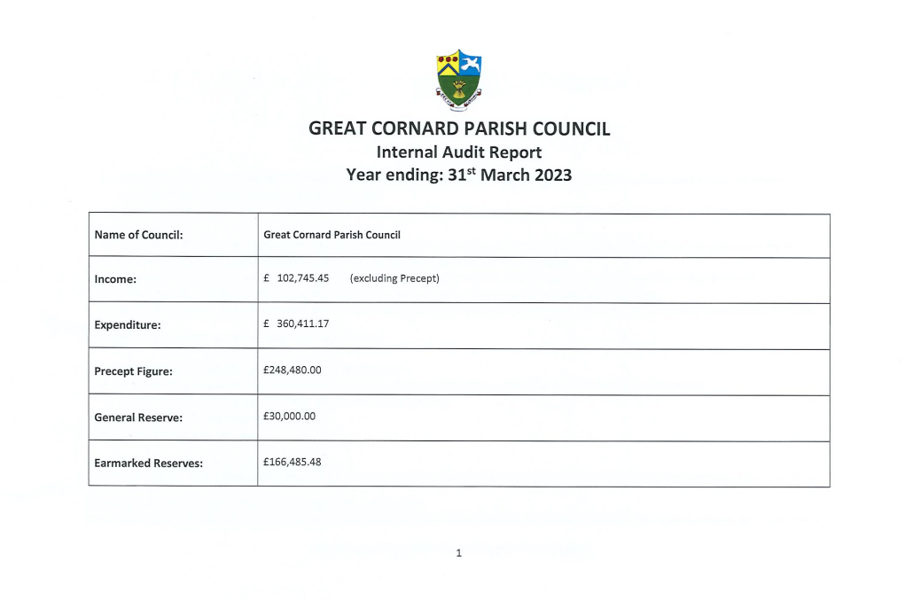

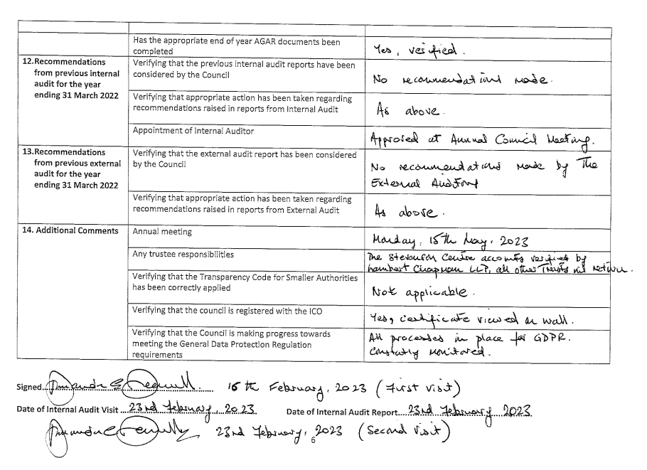



**APPENDIX F**

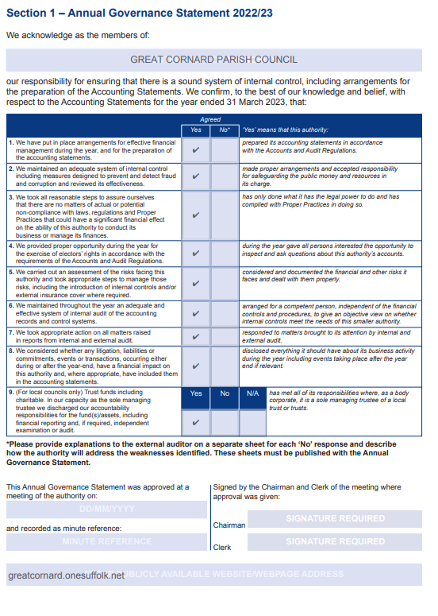

**APPENDIX G**

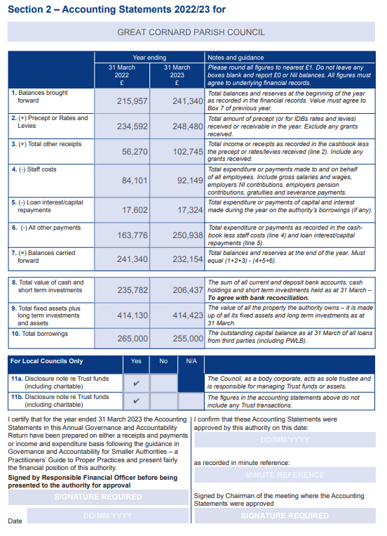

**APPENDIX H**

**APPENDIX I**

