GREAT CORNARD PARISH COUNCIL
Minutes of the Meeting of the DEVELOPMENT & PLANNING COMMITTEE
held in The Stevenson Centre at 7:00pm on Monday 25th September 2023

PRESENT Councillors Cllr Majorie Bark Chair

Cllr Kevin Graham Cllr Tim Hurst
Cllr Tom Keane Cllr Stewart Sheridan Cllr Colin Wright

Council Manager Mrs N Tamlyn
Council Administrator Miss E Skuce

1. APOLOGIES FOR ABSENCE

Apologies were received from Cllrs Jane Brooker, Melanie Keane and Pamela White.

2. DECLARATIONS OF INTEREST AND REQUESTS FOR DISPENSATIONS

NONE.

3. DECLARATIONS OF GIFTS AND HOSPITALITY

NONE.

4. ITEMS BROUGHT FORWARD – FOR NOTING

Members reviewed and NOTED the Items Brought Forward list.

5. CORRESPONDENCE

- Babergh District Council: Request for extra street signs at Raydon Way and Rede Way

Members considered correspondence from Babergh District Council which stated that following a number of residents of Rede Way contacting their Address Management Department about lost parcels and incorrect deliveries, they were suggesting new additional ‘clearer’ road signs be installed with the Parish Council bearing the costs, being £998.70 plus £120 for delivery. It was NOTED that Babergh District Council only cover the cost of replacement signs if they have been lost or damaged.

Members discussed that the Parish Council had no available funds to support the request and it was suggested that the District Councillors for Great Cornard be contacted to see if there are any locality funds available and it was AGREED for the Council Manager to contact them accordingly and report back at a future meeting.

6. TO RECEIVE AN UPDATE ON LAND FOR SALE AT RADIATOR ROAD

The Council Manager advised that following an enquiry from a member of the public at the Full Council meeting in July 2023, regarding the land off Radiator Road, including land forming Melso Close, Babergh District Council had confirmed that the development’s Section 106 Agreement identified the land as public open space, although Babergh’s interactive mapping system confirmed that they do not maintain it. It was NOTED that the land was currently up for sale with Savills Auctions in London but the advertisement did not mention that it was public open space.

It was AGREED for the Council Manager to contact Savills and advise them that the land is public open space and is subject to a Section 106 Agreement with Babergh. The Council Manager would also endeavour to establish who has been maintaining the land and update the Committee at a future meeting.

7. TO RECEIVE AN UPDATE ON APPLICATIONS FOR TWO NEW DOG WASTE BINS AT HIGHBURY WAY AND JOES ROAD

Members NOTED that in relation to Highbury Way, following a site visit by the Council
Manager and Councillor White, a slightly different location had been identified to the one
originally requested by the member of public. The grass verge on the opposite side of Highbury Way, at the junction with Pot Kiln Road, was felt to be a more suitable location for a dog waste bin as the other verge was also the subject of a memorial bench application and it would not be appropriate to site the two together (see Appendix A).

The cost of a new dog waste bin was £115.68 plus VAT and delivery from Glasdon UK.

The cost of Babergh District Council emptying the bin was £46.53 per annum.

It was agreed to RECOMMEND to Full Council that it purchases a new dog waste bin from Glasdon UK at a cost of £115.68 plus VAT and delivery for the Highbury way application.

Funds to come from the Recreation Ground Budget and the emptying costs from the Litter and Dog Bin Fund.

In relation to the suggestion of Joes Road for a new dog waste bin, Members noted that following a site visit by the Council Manager and Councillor White, two potential locations had been identified. It was agreed to RECOMMEND to Full Council, the installation of a bin subject to an application to Babergh to establish if either or both of the locations are suitable and meet their requirements for emptying (see Appendix A).

8. TO RECEIVE AN UPDATE ON AN APPLICATION FOR A NEW GRIT BIN ON THE FOOTPATH OFF WELLS HALL ROAD

Members were reminded that the purchase of a new grit bin at a cost of approximately £100 plus VAT had already been agreed at the Full Council meeting in September 2023. However, the Council Manager was tasked, at that time, with identifying a more precise location.

It was originally thought that Abbas Walk off Wells Hall Road was the preferred location but it had been established that the member of the public had actually wanted the footpath off Wells Hall Road leading down towards the school. The Council Manager and Councillor White had visited the footpath and identified a patch of grass which was felt was the best location (see Appendix B).

A member raised concerns over this particular patch of grass as they were aware that it is known to be used for parking at school drop off and pick up times.

It was agreed to RECOMMEND to Full Council that it purchases a new grit bin at an approximate cost of £100 plus VAT and agrees the location subject to an application being made to Suffolk County Council for their permission. The Council Manager to highlight the parking to SCC in the application.

9. TO RECEIVE AN UPDATE ON THE STREETLIGHT UPGRADES

Members reviewed and NOTED Report G04 in relation to the streetlight upgrade programme (see Appendix C).

10. TO CONSIDER NEW PLANNING APPLICATIONS

NONE.

Meeting closed at 7:24pm

APPENDIX A

Applications for dog waste bins at Highbury Way and Joes Road (deferred from D&P July 2023 meeting)
Members may recall, at the meeting of the Development and Planning Committee on 24th July 2023, it was agreed to defer both applications until the Council Manager and Councillor White had had the chance to visit the locations and consider suitable locations, which has now happened.

Application 1 – Highbury Way
The applicant originally asked for a dog waste bin to be placed on the grass verge opposite to the one shown below but as that was also the subject of a memorial bench application, it was felt that the verge opposite would be a better position.
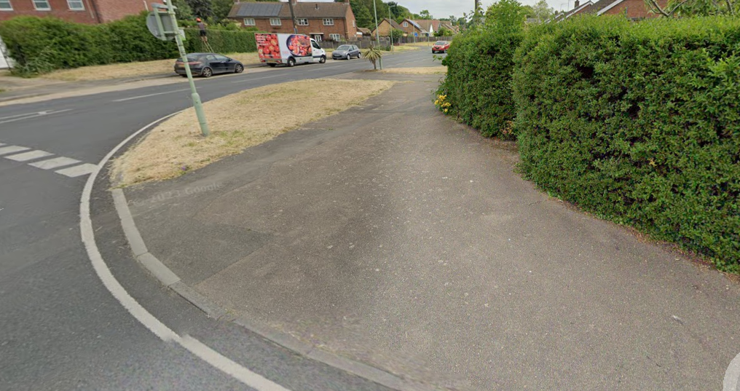
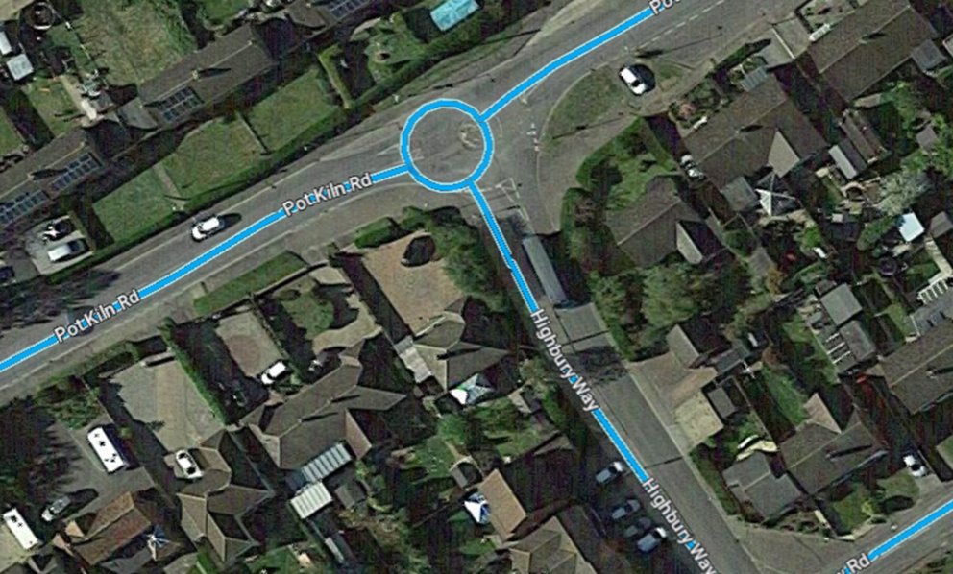

Application 2 – Joes Road
The applicant asked for a dog waste bin to be placed along one of the footpaths in the vicinity of Joes Road but was not specific as to exactly where. The Council Manager and Councillor White visited the area and two suitable locations were identified and are shown below (top suggestion 1, bottom suggestion 2).
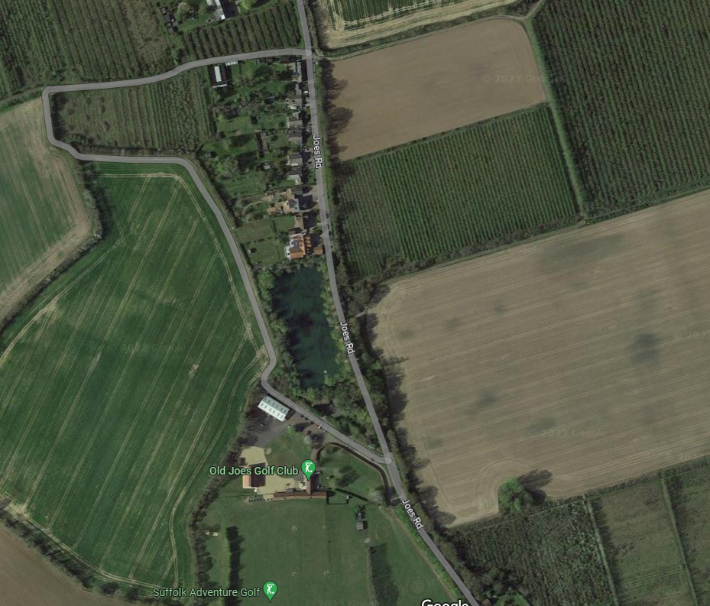

Suggestion 1
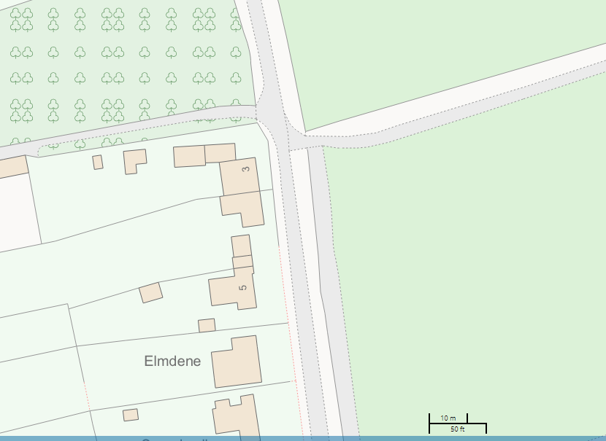

Suggestion 2
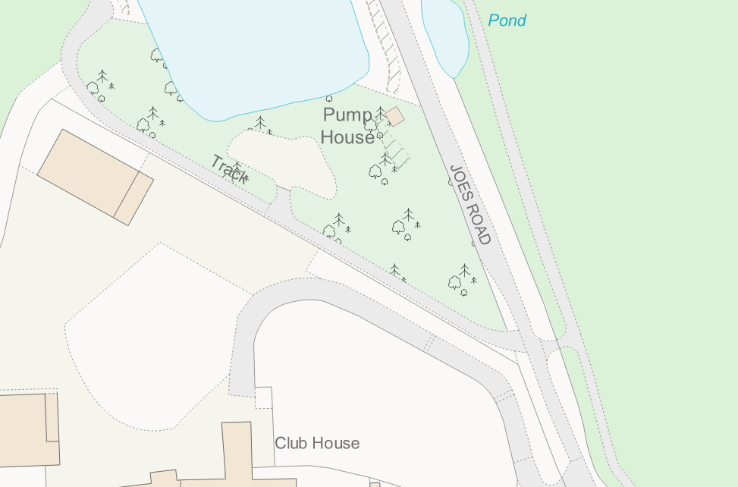

Recommendation: that Members agree to purchase two new dog waste bins; one to be placed at the suggested location on Highbury Way and one to be placed at either of the suggested locations on Joes Road, subject to Babergh District Council’s approval on whichever site is most suitable.
The cost of a 25L dog waste bin from Glasdon UK is £115.68 plus VAT.

Funds to come from the Recreation Budget.

APPENDIX B
New Grit Bin – Confirmed Location
Following the Full Council meeting on 11th September 2023, Members agreed to purchase two replacement grit bins on Prospect Hill and Canhams Road. It was also agreed to purchase a new grit bin on Abbas Walk once the Council Manager had clarified a more precise location with the resident who had requested it. Upon further investigation, it was confirmed that it was the footpath adjacent to Abbas Walk, leading down to the school, rather than Abbas Walk itself. The Council Manager and Councillor White visited the site and the preferred location is marked on the map below.

Footpath off Wells Hall Road – suggested location
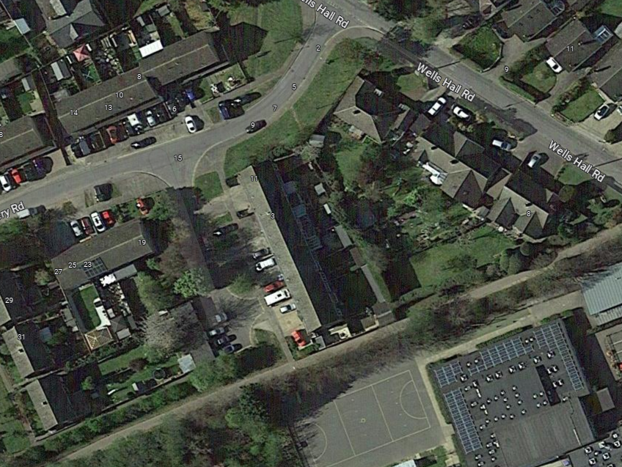

Recommendation: although the purchase of a new grit bin (at an approximate cost of £100 plus VAT) has already been agreed by Members, it is proposed that the new grit bin should be located just off of the footpath leading down to the school from Wells Hall Road. If the location is agreed, the Parish Council will still need to apply to Suffolk County Council for approval.

APPENDIX C

Report No: G 04
Update on the Parish Council’s Streetlight Upgrade Programme

Phase 1, stage 1 - completed
The two units that were outstanding on Cats Lane have now been completed. Once the units are checked, Suffolk County Council will send a final invoice for this stage.

Phase 1, stage 2 – remaining units to be re-costed
Suffolk County Council have advised that when their new contractors take over in October, they will be asked to re-price the remaining streetlights and then units can be prioritised based on the Budget available. It is hoped that the costings will be similar to the first stage of phase 1 as SCC have had new tendered rates but as some of the items included in the rates have changed, this cannot be confirmed until the prices are received. The works cannot be allocated to SCC’s current contractor as the contract will have expired and they will no longer be present in the Suffolk area.

