

**GREAT CORNARD PARISH COUNCIL**

Minutes of the Meeting of the **DEVELOPMENT & PLANNING COMMITTEE**

held in The Stevenson Centre at 7:00pm on Monday 26th September 2022

**PRESENT**  Councillors Mrs P White **Chairman**

Mrs M Bark Mrs S Bowman

K Graham D Young

Council Manager Mrs N Tamlyn

Council Administrator Miss E Skuce

**1. APOLOGIES FOR ABSENCE**

Apologies were received from Councillors T J Keane, Mrs C J Baker and Mrs T E A Welsh.

**2. DECLARATIONS OF INTEREST AND REQUESTS FOR DISPENSATIONS**

Councillor Young declared a non-pecuniary interest in any matter relating to Thomas Gainsborough School as he and a family member are employed by the Trust.

**3. DECLARATIONS OF GIFTS AND HOSPITALITY**

**NONE.**

**4. ITEMS BROUGHT FORWARD – FOR NOTING**

Members reviewed and **NOTED** the Items Brought Forward list.

**5. CORRESPONDENCE**

1. **Resident request for a new bus stop at Shawlands Avenue**

Members reviewed a request from a member of the public who had enquired about installing a new bus stop along Shawlands Avenue, close to the Woodland Rise development. The Council Manager stated that some support for the new bus stop had been noted on social media.

Whilst some members expressed concerns over the proposed location as it was close to a busy junction, it was **AGREED** that the Council Manager would submit the application for a new bus stop at a location between Stacey Ardley and the junction with Grace Farrant Road. Once the application form has been submitted and assessed by Suffolk County Council they can provide the Parish Council with an estimate of costs if they deem the location acceptable.

**6. TO CONSIDER LOCATIONS FOR NEW BENCHES THROUGHOUT THE VILLAGE TO COMMEMORATE THE QUEEN’S PLATINUM JUBILEE**

Over the Summer, Councillors had been asked to consider suitable locations for new benches throughout the village. Members reviewed a list of suggested locations and agreed that the main arterial roads throughout Great Cornard would be good locations to start with as they are longer routes and the benches would provide rest stops for walkers. Additional locations were added to the suggested list and attached at **Appendix A.**

**7. NATIONAL GRID: BRAMFORD TO TWINSTED CONSULTATION (REFERRED FROM FULL COUNCIL ON 12TH SEPTEMBER 2022)**

Members reviewed the Consultation Feedback Form which was due to be submitted by 19th October 2022. It was **AGREED** that Councillor Mrs White would liaise with the Council Manager and they would complete the Feedback Form on behalf of the Council.

**8. TO RECEIVE A REPORT ON DAMAGE TO THE BUS SHELTER AT HIGHBURY WAY**

Members reviewed Report F04 **(see Appendix B)** containing photographs of damage caused to the bus shelter at Highbury Way which is in the Council’s ownership. It is alleged that an Amazon delivery vehicle had hit the shelter and driven off. Suffolk County Council had attended to make the shelter safe, as is their duty, but had since confirmed that the structure had been damaged to the point where it may need to be removed. Suffolk County Council have been asked to provide two quotations, one to remove the shelter and one to replace it. A response was awaited. The damage has been reported to the Police and an insurance claim has been lodged with the Council’s insurers Zurich. Members agreed that they would prefer to see the shelter replaced rather than removed. It was **AGREED** that the Council Manager will investigate costings and report back to a future Committee.

**9. TO CONSIDER THE FORM TO NOMINATE THE FIVE BELLS PUB AS AN ASSET OF COMMUNITY VALUE**

Members had been provided with some guidance notes on Assets of Community Value and an application form which would need to be completed and submitted if the Council decided to progress the matter.

The Council Manager explained that the Council would need to demonstrate the community value of the asset and how the building could be acquired and used in the future and that Members would need to consider how to evidence its response to these questions.

A Member highlighted that the area used to be a row of commercial buildings and was a core part of the village and that it would be a shame to lose such an asset. Members agreed but given the pub’s current circumstances, and the fact that it had already been sold, it may prove difficult to pursue the ACV application.

It was **AGREED** for the Council Manager to contact Babergh District Council and see if they had an officer who specialised in assets of community value and obtain some advice and report back to a future meeting.

**10. TO RECEIVE AN UPDATE ON THE QUIET LANES SCHEME**

Members reviewed correspondence from Suffolk County Council which informed that Cadent Gas had raised concerns over the installation of a new post at position 5 at Joes Road, as it was very close to their main gas line. It had subsequently been agreed to install a small post opposite the junction to remind drivers of the Quiet Lane but have no exit sign.

Suffolk County Council’s legal department had advised that Parish Councils should enter into a formal arrangement with SCC regarding the self-installation of signs. However, it was **NOTED** that the Parish Council is awaiting a response from SCC as to whether the arrangement is needed as the Community Wardens hold the required street works qualification.

**11. TO CONSIDER NEW PLANNING APPLICATIONS**

Members **NOTED** that no new planning applications had been received.

Members also **NOTED** a Decision received from Babergh District Council which was contrary to the Parish Council’s recommendation.

**DC/22/03852 – 145 Bures Road, Great Cornard**

**Erection of two storey rear extension and construction of detached garage**

**Parish Council recommended refusal on the following grounds:-**

Overdevelopment of the site

Given the recent application to convert the garage into additional living space which has been approved, the Parish Council believes the applicant’s new submission to extend the property further and build a new detached garage constitutes overdevelopment of the site.

**Babergh District Council – Granted Permission**

**Meeting closed at 7:28pm**

**APPENDIX A**

**List of suggested locations for commemorative benches**

Main arterial roads

* Bures Road
* Shawlands Avenue
* Canhams Road
* Head Lane
* Newton Road
* Maldon Court leading to Cats Lane via Maldon Grey PH
* Pot Kiln Road
* Cats Lane (either side)

Other Village locations

* Green by play equipment at Maldon Court (owned by SCC/BDC)
* Village Green away from the play area – perhaps by the Village sign
* Green on Queensway (Pot Kiln Road end) (owned by SCC/BDC)
* Green opposite the shops at Poplar Road (near bus stop) (owned by SCC/BDC)
* By the river at Dove House Meadow (in private ownership)
* Land north east of Shawlands Avenue (highest point of the Great Cornard Walk)
* Green adjacent to Kings Head PH (owned by SCC/BDC)

**APPENDIX B**

**Report F04**

**Damage caused to bus shelter at Highbury Way**

The Parish Council received an email from Suffolk County Council on the 25th August 2022 informing that the bus shelter at Highbury Way, which is in the Council’s ownership, had sustained damage. The matter had been reported to them by a member of the public. Photos of the damage below:-

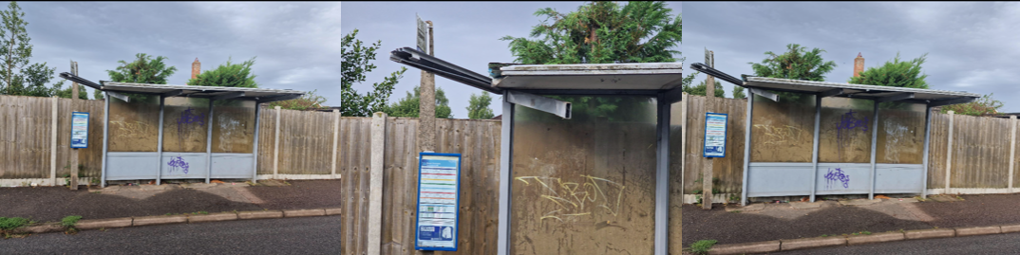

Suffolk County Council attended and made the shelter safe. Whilst on site, a member of the public told the officers that they believed an Amazon delivery van had caused the damage but had driven off. The photo below shows the shelter after SCC had attended to make safe:-

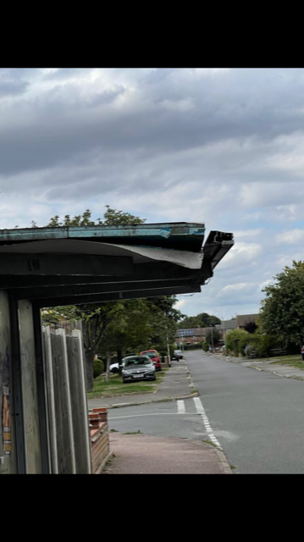

Suffolk County Council have since advised that although it has been made safe, the structural damage caused may mean that the shelter has to be removed. SCC have offered to provide quotation to remove the shelter and the Parish Council has also asked if they would quote to replace it as well. The Parish Council can also seek alternative quotes elsewhere in the meantime.

A Police report has been submitted for criminal damage and an insurance claim started with Zurich Insurance.