GREAT CORNARD PARISH COUNCIL
Minutes of the Meeting of the DEVELOPMENT & PLANNING COMMITTEE
held in The Stevenson Centre at 7:00pm on Monday 24th July 2023

PRESENT Councillors Cllr Pamela White Chair

Cllr Marjorie Bark Cllr Tim Hurst
Cllr Melanie Keane Cllr Tom Keane Cllr Stewart Sheridan Cllr Colin Wright

Council Manager Mrs N Tamlyn
Council Administrator Miss E Skuce

1. APOLOGIES FOR ABSENCE

Apologies were received from Cllrs Jane Brooker and Kevin Graham.

2. DECLARATIONS OF INTEREST AND REQUESTS FOR DISPENSATIONS

NONE.

3. DECLARATIONS OF GIFTS AND HOSPITALITY

NONE.

4. ITEMS BROUGHT FORWARD – FOR NOTING

Members reviewed and NOTED the Items Brought Forward list.

5. CORRESPONDENCE

- Local Resident: Suggested location for a commemorative bench

Members reviewed correspondence from a local resident who had suggested that the grass verge at the junction of Highbury Way and Pot Kiln Road would be a suitable location for a new memorial bench.

The Council Manager advised that five preferred locations had already been identified and two benches purchased with one of those already installed at Kings Hill and the other due to be installed on Abbas Walk. Any further locations agreed would need to be added to the list for future consideration.

It was AGREED to add this location to the list for future consideration and for the Council Manager to write to the resident accordingly.

6. TO CONSIDER REQUESTS FROM LOCAL RESIDENTS FOR TWO NEW LITTER BINS

Cllr Tim Hurst arrived to the meeting at 7:06pm

Members considered requests from two residents for new litter bins to be installed; one at Highbury Way on the grass verge opposite the new bus shelter and one at Carsons Drive, on the grass verge near the junction with Lionel Hurst Close. Both locations had been confirmed by Babergh District Council as acceptable.

It was NOTED that the cost of a new Community Litter Bin from Glasdon UK was £240.13 plus VAT and the cost of emptying a litter bin was currently £39.73 per annum.

Members agreed to RECOMMEND to Full Council that it purchases two new Community Litter Bins from Glasdon at a cost of £480.26 plus VAT. Funds to come from the Recreation Budget.

Emptying costs of £39.73 per bin, per annum to Babergh District Council to come from the Litter and Dog Bin Budget.

7. TO CONSIDER REQUESTS FROM LOCAL RESIDENTS FOR TWO NEW DOG WASTE BINS

Members considered requests from two residents for new dog waste bins to be installed; one at Highbury Way, on the grass verge at the junction of Pot Kiln Road and one at Joes Road, on a nearby footpath which is yet to be identified by the resident.

It was NOTED that the location on Highbury Way was also a suggested location for a commemorative bench discussed earlier in the meeting. Joes Road could not be fully considered as the resident was yet to respond with a more precise location.

It was AGREED to defer both requests to a later meeting. This would allow the Council Manager and Cllr White to visit both Joes Road and Highbury way over the summer break and identify suitable locations.

8. TO RECEIVE A REPORT ON THE CONDITION OF THE GRIT BINS IN THE VILLAGE

Members considered a Grit Bin Audit (see Appendix A) which showed the locations and condition of each grit bin in the village. The Council Manager explained that the Parish Council is responsible for purchasing the grit bins and Suffolk County Council provides the sand/salt for gritting.

The Audit showed that two of the grit bins were broken and needed replacing; one at Prospect Hill and one at the top of Canhams Road. It was NOTED that the cost of a new grit bin was approximately £100 plus VAT and any relevant delivery. Funds would come from the Recreation Budget.

The Audit also informed that two requests for grit bins had been received; one for Joes Road which had been refused by Suffolk County Council as the location was on a Priority 2 gritting route and on Abbas Walk but the resident was yet to confirm a more precise location.

Members agreed with the Audit’s recommendation and agreed to RECOMMEND to Full Council that it purchases two replacement grit bins for Prospect Hill and Canhams Road at an approximate cost of £200 plus VAT and delivery.

In addition it was agreed to RECOMMEND to Full Council that it purchases a further grit bin for Abbas Walk once the Council Manager had been able to confirm a more precise location with the resident.

9. SUFFOLK ROAD SAFE: AUTOMATIC NUMBER PLATE RECOGNITION (ANPR) PROJECT

The Council Manager informed Members that Suffolk County Council, in partnership with the Police and Crime Commissioner and the Constabulary (the Suffolk Roadsafe Partnership), were trialling the use of ANPR cameras to tackle speeding hot spots across the County. The Parish Council could apply to be part of the scheme, using the existing SID locations throughout the village.

A Member asked whether, whilst the ANPR cameras were in situ, the Parish Council’s SID unit would operate as usual and whether the data was still collected in the same way. It was AGREED for the Council Manager to contact Suffolk County Council and clarify the matter.

Members AGREED for the Council Manager to submit applications to SCC for an ANPR camera to be used in Great Cornard on existing SID poles at Canhams Road, Bures Road and Poplar Road.

10. TO RECEIVE AN UPDATE ON THE BEESTON’S NO.91 BUS SERVICE – SATURDAY CANCELLATION

Members NOTED that due to the County Council providing part-subsidy, the decision to cancel the no. 91 service between Sudbury and Hadleigh on a Saturday, had been reversed.

11. TO CONSIDER NEW PLANNING APPLICATIONS

- DC/23/03233 – 24 Jacobs Close, Great Cornard
Application for works to a tree protected by TPO BT382(T1) – Reduce 1 no. Ash (T1) by 30%

Recommended - APPROVAL

- DC/23/03275 – The Laurels, 11 Kings Hill, Great Cornard
Change of use from chiropractic clinic to a residential children’s home.

Recommended – REFUSAL on the following grounds:-

Traffic and Safety Concerns
The plans do not show the entrance properly secured by appropriate measures such as a gate or fence. The Parish Council is therefore extremely concerned for the safety of the children as Kings Hill/Bures is a very busy road.

Kings Hill/Bures Road is already extremely busy and the addition of vehicles coming and going from this property would only exacerbate the situation.

- DC/23/03196 – 9 Windmill Close, Great Cornard
Conversion of and extension to garage, to form residential annexe for dependant relative and erection of detached summer house.

Recommend – APPROVAL

- DC/23/03326 – 8 The Pot Kilns, Great Cornard
Construction of raised roof and first floor extension to property (following demolition of existing roof area) including alterations to fenestration and exterior appearance (re-submission of DC/22/06118).

Recommend – REFUSAL on the following grounds:-

The Parish Council retains its objections to this application and repeats the grounds on which it recommended refusal for DC/22/06118, which were:-

Recommended REFUSAL on similar grounds as the Parish Council’s previous objections to refused application DC/21/05281, which are:-
- Increase in size of property not in keeping with the area which is predominantly single storey bungalows.
- Insufficient parking for size of property and insufficient space for manoeuvring of vehicles.
- Increase in traffic along single track road.
- The Parish Council notes the previous case officers reason for recommending refusal of application DC/21/05281 i.e., the proposed development is considered to result in a significant adverse impact on residential amenity and the character of the area. That application was subsequently refused by the Planning Authority and the Parish Council strongly believes that this new application is still overdevelopment of the site and not in keeping with the surrounding area.

Meeting closed at 7:39pm

APPENDIX A
Great Cornard Parish Council – Grit Bin Audit
Poplar Rd/Shawlands Ave  Empty and requires filling | 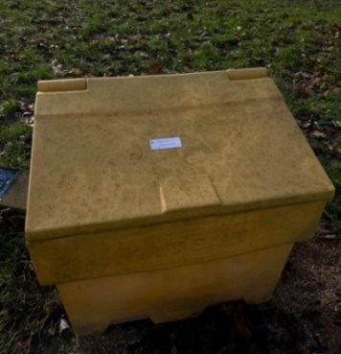
Prospect Hill  (half way up on the bend) | 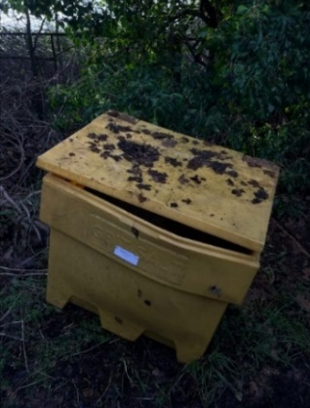
Bures Road/Head Lane  Vegetation overgrown and needs cutting back | 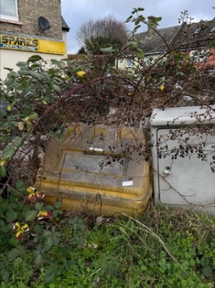
Eldred Drive  Half full | 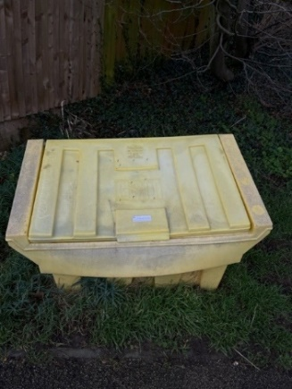
Canhams Road (top)  Broken and needs replacing | 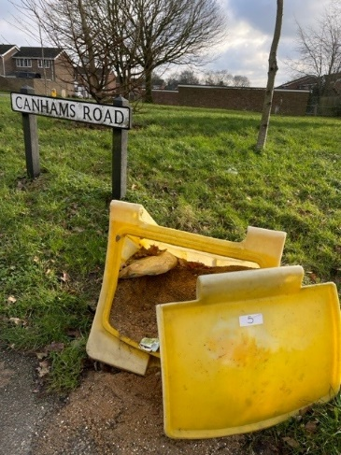
Wells Hall Road/Canhams Road

Kempson Drive | 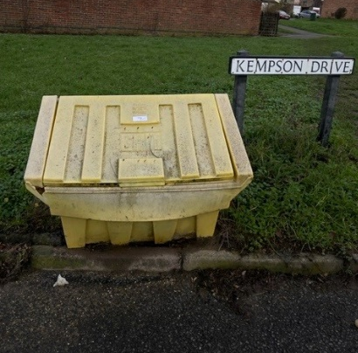
Raydon Way | 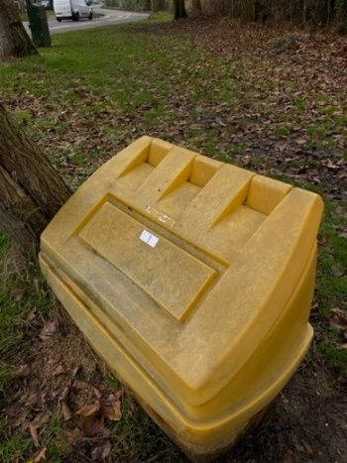
Stannard Way/Broom Street | 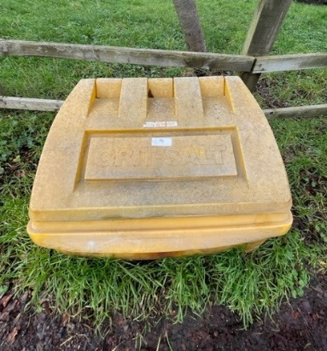
Sycamore Road | 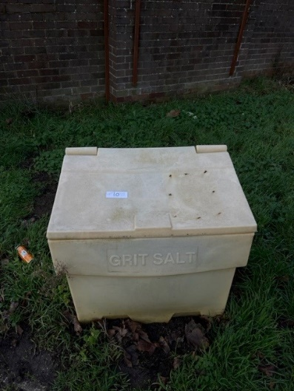
The Stevenson Centre
Chelsworth Avenue | 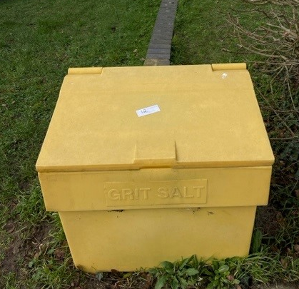
Hawthorn Road  Half full | 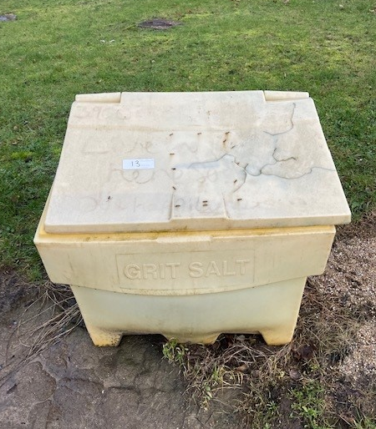
Poplar Road (near steps)  Empty and needs replacing | 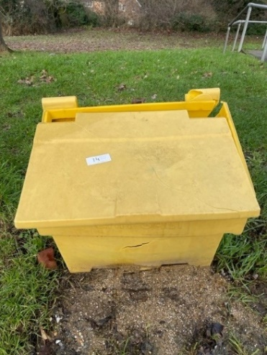
Bakers Mill  Half full | 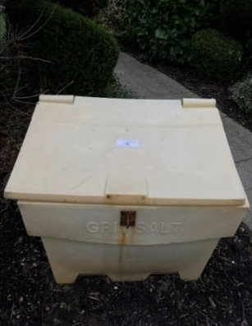
Clover Court | 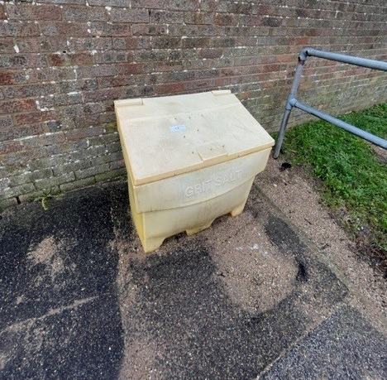
Chelsworth Avenue (bottom by 61) | 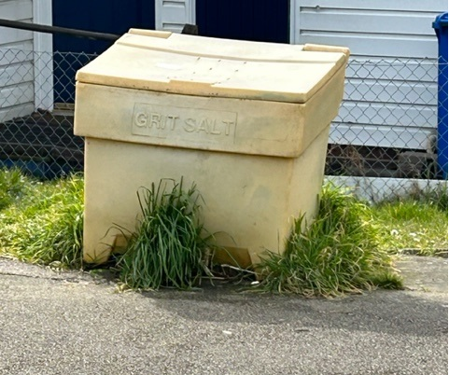
Prospect Hill
Broken and needs replacing

The Parish Council has undertaken a full audit of all of its grit bins in the village. Two grit bins are broken and will need replacing. The current cost of a new grit bin is approximately £100 plus VAT and relevant delivery charge. Funds to come from the Recreation Budget.
Two requests for grit bins have also been received from members of the public.
- Joes Road at the junction with Prospect Hill – an application was sent into Suffolk County Council to see whether it was a suitable location for a new grit bin. As the location is on a priority 2 gritting route, it was deemed an unacceptable location and the request was refused.
- Abbas Walk off Wells Hall Road – the Parish Council is awaiting a response from the resident as to a more precise location before it can submit any application to Suffolk County Council.

Recommendation: To recommend to Full Council that it purchases two replacement grit bins at the top of Canhams Road and at Prospect Hill at an approximate cost of £200 plus VAT and delivery. The Council manager to liaise with the resident to identify a suitable grit bin location on Abbas Walk (off Wells Hall Road).

