

**GREAT CORNARD PARISH COUNCIL**

Minutes of the Meeting of the **DEVELOPMENT & PLANNING COMMITTEE**

held at The Stevenson Centre at 6.45pm on Monday 12th June 2023

**PRESENT** Councillors Cllr Pamela White **Chairman** Cllr Marjorie Bark Cllr Jane Brooker Cllr Melanie Keane Cllr Tom Keane Cllr Stewart Sheridan Cllr Colin Wright

Council Manager Mrs N Tamlyn

Council Administrator Miss E Skuce

1. **APOLOGIES FOR ABSENCE**

Apologies were received from Cllr Kevin Graham.

1. **To consider Declarations of Interests and Councillor Requests for Dispensations relating to items on the Agenda**

Cllr Bark declared a non-pecuniary interest in Item 5d) as 182a Bures Road borders her own private residence.

1. **dECLARATIONS OF GIFTS AND HOSPITALITY**

**NONE**

1. **TO RECEIVE AN UPDATE ON THE COMMEMORATIVE BENCHES IN THE VILLAGE**

Members considered and **NOTED** Report No. G01 which provided updates on each of the five agreed locations for commemorative benches within the Village **(see Appendix A)**.

Members **AGREED** with the Report’s recommendation to accept the County Council’s offer to include locations 3 and 4 in one street furniture licence application and for the Council Manager to submit the application and pay the fee of £150.

Funds to be allocated from the Recreation Budget.

1. **TO CONSIDER NEW PLANNING APPLICATIONS**
2. **DC/23/02153 – 11 Maldon Court, Great Cornard**

Householder application: Erection of single storey rear extension

Recommended - **APPROVAL**

1. **DC/23/02297 – 4 Joes Road, Great Cornard**

Erection of single storey front porch extension

Recommended - **APPROVAL**

1. **DC/23/02345 – 16 Spicer Way, Great Cornard**

Conversion of and extension to garage to provide additional living accommodation

Recommended - **APPROVAL**

1. **DC/23/02601 – 182a Bures Road, Great Cornard**

Application under s73 for the removal or variation of a condition following grant of DC/18/02469 and subsequent NMA DC/22/01090 Town and Country Planning Act 1990 (as amended) – outline planning application (access layout and scale to be considered) – erection of up to 46 dwellings with vehicular and pedestrian access from Bures Road. Demolition of 182a Bures Road and storage building – to amend condition 3 (approved plans and documents) as per details received.

Recommended **– APPROVAL based on the amended plans received and on the understanding that the density of the development is not increased.**

**Meeting closed at 7:06pm**

**APPENDIX A**

**Report No: G01**

**Platinum Jubilee Commemorative Benches**

At the Full Council meeting on 3rd April 2023, Members agreed to progress the five locations shown below and purchase the Phoenix Bench from Glasdon with a memorial plaque at a cost of £686.39 plus VAT for each location.

**Location 1: Kings Hill (replacement bench)**

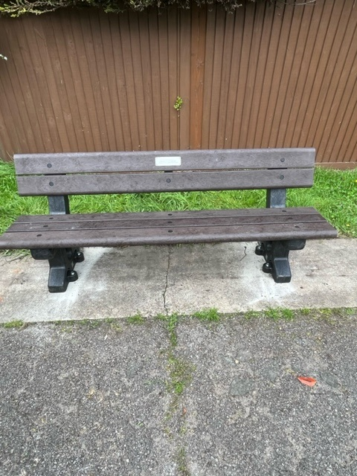

This Phoenix recycled plastic bench (with memorial plaque) was installed by the Community Wardens on the 3rd May and replaces an old broken bench next to the boundary signs between Great Cornard and Sudbury.

**Location 2: Abbas Walk (off Carsons Drive)**

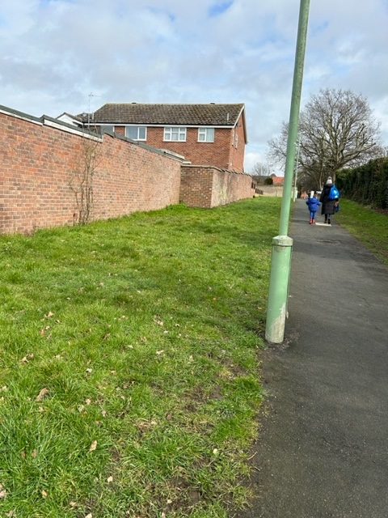



This area is owned and maintained by Babergh District Council. They have confirmed that the Parish Council can install a commemorative bench in this location. The Council can now proceed with an order to purchase the bench and plaque for installation as soon as possible.

**Location 3: Canhams Road (on the grass verge at the junction with Wells Hall Road)**

Land is owned by Suffolk County Council and a Street Furniture Licence will be required at a cost of £150*.

**Location 4: Stannard Way (on the grass verge near to the ‘Glenside’ bus stop**

Land is owned by Suffolk County Council and a Street Furniture Licence will be required, at a cost of £150*.

*Suffolk County Council have confirmed that they will accept one application with one fee of £150 for both locations (4 and 5) mentioned above.

**Location 5: Shawlands Avenue (opposite the junction with Kersey Avenue, on the hill by the entrance)**

Land is owned by Mr Drury and the Council Manager will contact Mr Drury regarding permission to install a bench in this location.

The Phoenix bench is still available from Glasdon UK at the same price of £585.00 plus VAT (with memorial plaque at the same price of £101.39 plus VAT) – total of £686.39 plus VAT. Funds to come from Earmarked Funds for Commemorative Benches.

**Recommendation:** to accept the County Council’s offer to include locations 3 and 4 in one application and for the Council Manager to submit the application and pay the street licence fee of £150.

However, there are no more available funds in the Commemorative Bench Budget and it is recommended that the fee be paid from the Recreation Ground Budget.