GREAT CORNARD PARISH COUNCIL
Minutes of the Meeting of the ART, SPORT & LEISURE COMMITTEE
held in The Stevenson Centre at 7:25pm on Monday 25th September 2023

Present: Councillors Cllr David Young Chair
Cllr Tony Bavington Cllr Sharon Bowman Cllr Kevin Graham Cllr Tim Hurst Cllr Tom Keane Cllr Jane Wakeman Cllr Colin Wright

Council Manager Mrs N Tamlyn
Council Administrator Miss E Skuce

- APOLOGIES FOR ABSENCE

Apologies were received from Cllrs Melanie Keane and Judith Wilson.

2. DECLARATIONS OF INTEREST AND REQUESTS FOR DISPENSATIONS

NONE.

3. DECLARATIONS OF GIFTS AND HOSPITALITY

NONE.

4. ITEMS BROUGHT FORWARD – FOR NOTING

Members reviewed and NOTED the Items Brought Forward List.

5. CORRESPONDENCE

- Cornard Dynamos: Cricket Pitch at Blackhouse Lane

Cllr Graham declared a non-pecuniary interest as he coaches the Cornard Dynamos under 9s team.

Members reviewed correspondence from Cornard Dynamos which explains that as the Club is growing, the playing fields at Blackhouse Lane are becoming too small to accommodate their needs. This is resulting in the Club paying to hire external facilities to ensure they can fulfil the needs of all their teams. The Leisure Centre have informed the Club that the Unity Trust intends to substantially change their pricing structure, meaning that the Club could struggle to afford to hire extra pitches. The Club states that the cricket pitch at Blackhouse Lane has not been used for some time and is seeking permission from the Parish Council to use the pitch to increase their available playing space and reduce the need to hire external spaces.

A Member was not in favour of giving up the cricket pitch as it would be an irrevocable decision and once the pitch is gone, it would not be possible to get it back. The Member reminded the Committee that Cornard Dynamos do not currently have a Lease and only have a Management Agreement in place.

A Member stated that the possibility of a ladies cricket team was brought up at the last meeting of the Cornard Leisure Centre Working Group and this would mean that there would be a reason for the pitch to remain. Cllr Bavington stated that he was due to attend a meeting with the Working Group next week and he may find out more about that then.

Members discussed the fact that the pitch had not been in use for some time and there did not seem to be any progress towards it becoming a playable surface. It was felt that if the pitch was not handed over to the Dynamos the Council could risk the club going elsewhere or losing the club altogether.

The Council Manager confirmed that she had tried several ways of securing the pitch’s upkeep and future, but had not been able to find another club to take over the area or a grounds person or company willing and able to take on the responsibility at a reasonable cost.

It was AGREED that further consideration would need to be given to the matter once Cllr Bavington had been able to provide an update on the potential ladies team. The matter would be discussed again at the next committee meeting.

6. TO RECEIVE THE NOTES FROM THE RECENT SITE INSPECTION OF THE BLACKHOUSE LANE PAVILION

Members reviewed the Notes following the meeting with Cornard Dynamos on the 14th August 2023 (see Appendix A).

The Council Manager advised that no monies had been set aside in this year’s Budget for any large repair bills. Members discussed other ways of funding the required works and a Member stated that as the club has no Lease, they are unable to apply for any grant aid available. Another Member suggested that District Councillors could be contacted to establish whether any locality funds are available.

Members AGREED for the Council Manager to seek quotes for works which are the Landlord’s responsibility and in relation to the guttering, to investigate a durable ‘vandal proof’ replacement to repair the damaged pipes.

In relation to the protection of the outside wooden fire door, it was AGREED for the Council Manager to contact the quantity surveyor who dealt with the refurbishment works at the Pavilion in 2021, including the installation of the door, and inform them that the door is already in a poor condition and in need of repair.

7. TO RECEIVE THE NOTES FROM THE RECENT SITE INSPECTION OF THE CORNARD UNITED CLUBHOUSE AND GROUNDS

Members reviewed and NOTED the Notes from the meeting with Cornard United on 14th August 2023 (see Appendix B).

A Member raised concerns about the Parish Council’s liability in relation to the current condition of the access road.

It was also NOTED that the Chairman of Cornard United had provided a quotation for the requested works and that this was due to be considered at the Policy and Resources meeting later in the evening.

8. TO RECEIVE A VERBAL UPDATE ON THE RECREATION GROUND PLAY AREA IMPROVEMENT PROJECT

The Council Manager confirmed that herself and the Chair had met with the contractor, Wicksteed, and the project was due to start mid to late October this year. The enclosed play area would need to be closed for approximately three weeks while the work is carried out.

In relation to the teen piece and adult exercise equipment which were to be located on the Recreation Ground, it had been agreed that they would be delivered to site and at that point, the Council Manager would meet Cllr Young and the resident of Queensway who had raised concerns over the items being located in close proximity to the bottom of their garden, to agree suitable positions. NOTED.

At 8:13pm Cllr Bavington left the meeting.

9. TO CONSIDER A QUOTATION FOR SECTION 59 SIGNAGE AT THE COUNTRY PARK CAR PARK, ALLOTMENT CAR PARK AND SHAWLANDS WOOD LNR

Following an incident at the Country Park car park and a recommendation from Babergh District Council’s Community Safety Officer, it was agreed for the Council Manager to obtain costings for Section 59 Police Warning signs to be located at the Country Park car park, Allotment car park and at Shawlands Wood LNR (see Appendix C).

Members reviewed a quotation received from Auto Innovations for £342.00 plus VAT to supply Section 59 signage; two small signs fixed to existing posts at the Allotment car park, two large signs (one on the wall and one mounted onto a new post) at the Country Park car park, and two signs (one large sign to be fixed to the existing wooden fence and one small sign fixed to an existing post) at Shawlands Wood LNR.

It was agreed to RECOMMEND to Full Council that it accepts the quotation from Auto Innovations for £342.00 plus VAT to supply 3 x large and 3 x small Section 59 signs plus a new post, to be installed by the Community Wardens, for the above locations.

Funds to come from the Recreation Budget.

10. TO CONSIDER A QUOTATION FOR SIGNAGE REGARDING HORSES IN THE COUNTRY PARK

Members considered a quotation from Auto Innovations for £171.00 plus VAT to set up, strip down and reuse/reprint the existing dangerous dogs signs at the Country Park, to include the wording ‘Horses are restricted to walking pace only’ (see Appendix D).

It was agreed to RECOMMEND to Full Council that it accepts the quotation from Auto Innovations for the sum of £171.00 plus VAT to amend the two existing dangerous dogs signs at the Country Park, to include the wording ‘Horses are restricted to walking pace only’.

Funds to come from the Recreation Budget.

11. TO RECEIVE A VERBAL UPDATE ON THE SUDBURY COMMON LANDS CHARITY AMENITY GRASS CUTTING CONTRACT

The Council Manager advised that both Rangers had now left Sudbury Common Lands Charity and had not yet been replaced. The Clerk to the Charity had confirmed that they would write to the Council and state their intention to end the amenity grass cutting contract with the Parish Council at the end of March 2024. The contract area includes the Recreation Ground, Stacey Ardley and the Village Green. NOTED.

At 8:16pm Cllr Bavington re-joined the meeting.

12. TO CONSIDER AN APPLICATION FOR A MEMORIAL BENCH AT THE COUNTRY PARK

Members considered an application received for a memorial bench at the Country Park where the applicant had given two preferred locations. The first of which had already been advised as unsuitable by Sudbury Common Lands Charity as it very close to sensitive flora including bee orchids. A bench there could also obstruct their vehicles from accessing that part of the park, and therefore affect their management of it.

There are already two memorial benches in the vicinity of the applicant’s second preferred location and it may not be suitable for a third to be placed there. Sudbury Common Lands Charity had advised previously that by the Jubilee Oak would be a suitable position for a memorial bench.

It was AGREED that the Council Manager and Cllr Young would visit the site to view possible alternatives and then liaise with the applicant to try and agree a precise location.

Meeting closed at 8:23pm

APPENDIX A
Notes from Meeting with Cornard Dynamos at 6pm on Monday 14th August 2023
Attendees: Councillors Sharon Bowman and David Young; Council Manager Mrs N Tamlyn; Chairman of Cornard Dynamos Kieran Whiting (KW); Secretary to Cornard Dynamos Julie Byham; and Treasurer of Cornard Dynamos Steve Arnold (SA)
Apologies: Councillor Tom Keane.

Members viewed the plastic down pipes which were broken or missing in places. The CM advised that a section had already been fixed, but it was clear that without the installation of the same metal brackets used on the guttering, the problem would continue. ACTION PC to consider options and costings.
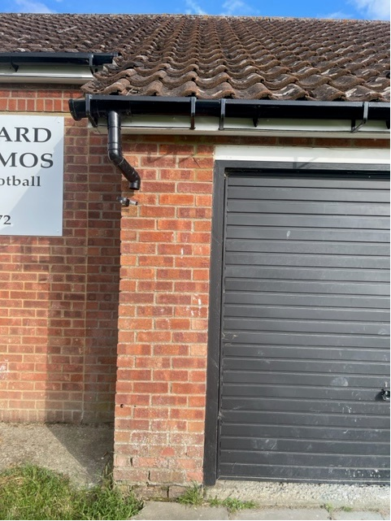
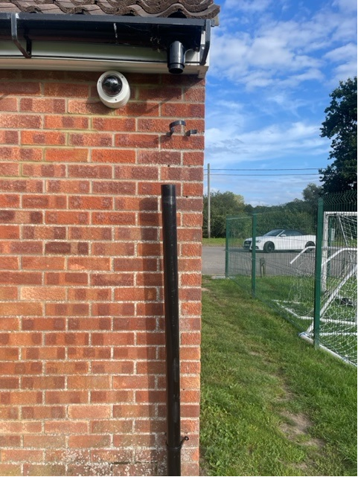

It was suggested that the outside wooden fire door (below) be fitted with a metal sheet to stop it from rotting.
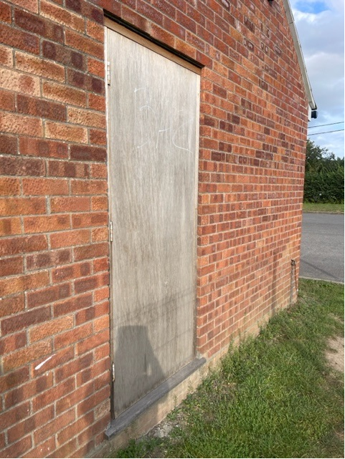
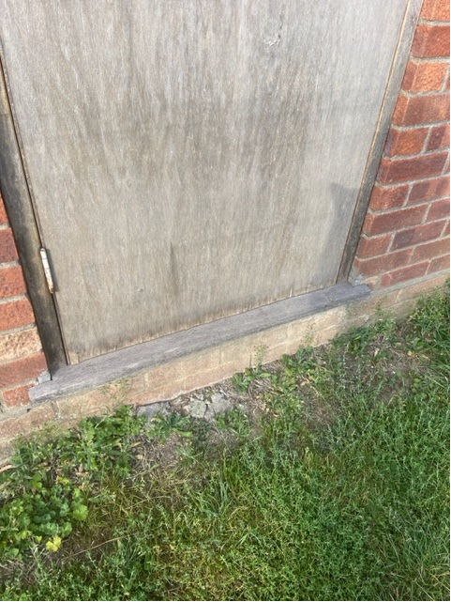

The Club confirmed that they no longer use the showers and the CM agreed to ask the Council’s plumber to quote on the work needed to remove the showers from action and ensure there were no remaining dead legs in place.
Following last year’s cold spell which resulted in several water leaks, it was suggested that the plumber also assess the insulation around the pipes and advise on whether any additional insulation was needed.
The Club advised that they’d repaired the ceiling in the ladies toilets following a leak and asked if the Council would reimburse the cost of the materials. ACTION KW to submit the invoice to the Council for consideration.
The Club asked if the Council would consider replacing the current taps with push taps and change all the lights to LEDs, as they struggled to ensure they were switched off. The CM advised that the Council’s Budget for repairs was limited and it was unlikely to be considered a priority, especially as the solution was for whoever locked up the building to check that everything was switched off first.
Members viewed all the rooms and the Club advised that several pots of paints had been donated to decorate the inside of the Pavilion. ACTION CM to provide the details of Catch 22 to assist with the painting.
The Club have been donated a new kitchen window and asked for permission to install the window at no cost to the Council. ACTION for the Club to write to the Council to seek permission.
Questions were asked about the location of the outlets for the kitchen vent and the extractor hood, as the Club were concerned that both the outlets were in the roof and could be a fire hazard. ACTION CM to ask the Council’s electrician’s advice.
The Club confirmed that they are doing well at the moment but are struggling to hold the number of football matches needed as there is not enough space and they are having to hire extra pitches, at considerable cost, from TGS. The Club asked the current position with regards to the cricket square as the extra space would allow them to install at least two more pitches. Members advised that the Council were keen to maintain the option of playing cricket in Great Cornard and suggested they write to the Council to advise the issues caused by the lack of space.

APPENDIX B
Notes from Meeting with Cornard United at 4pm on Monday 14th August 2023
Attendees: Councillors Sharon Bowman and David Young; Council Manager Mrs N Tamlyn; Cornard United Chairman Tom Clark (TC)
Apologies: Councillor Tom Keane.

Members first viewed the condition of the access road and driveway lights. It was noted that a bollard had been knocked over and wasn’t working and another just flickered. TC advised that both lights have been isolated and suggested that once the lights are fixed that they could be cemented into the ground. ACTION TC to provide quotations for materials.
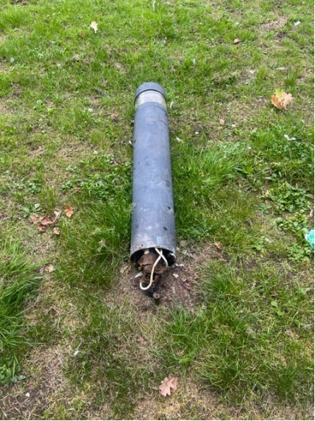

Members reviewed the condition of the access road and noted its poor condition in several places. The Club highlighted their concerns as they could be reported to the Footbal Association if the access for emergency vehicles was impassable. ACTION TC to provide a quotation to dig out and remove the roots and repair the road with both a temporary and permanent option provided.

TC also highlighted the need for a pedestrian path around the access gate for when it’s closed. CM advised that this had been brought up before by the Club and that the Council had asked for a plan and costings to be submitted, which could be considered in time for the next Budget. ACTION TC to provide costings and a plan.
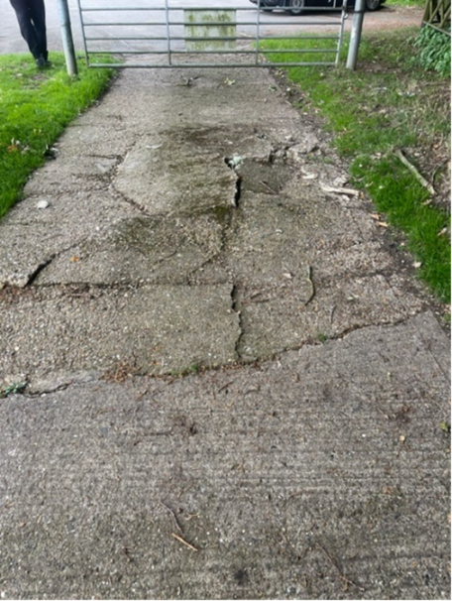

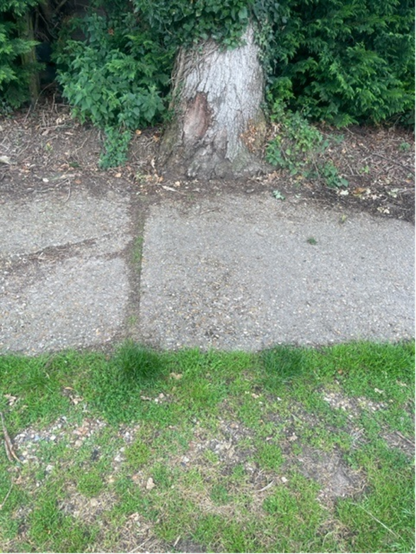
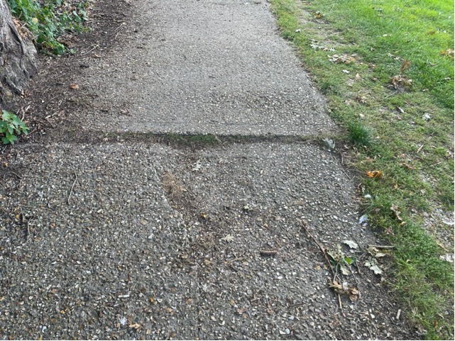

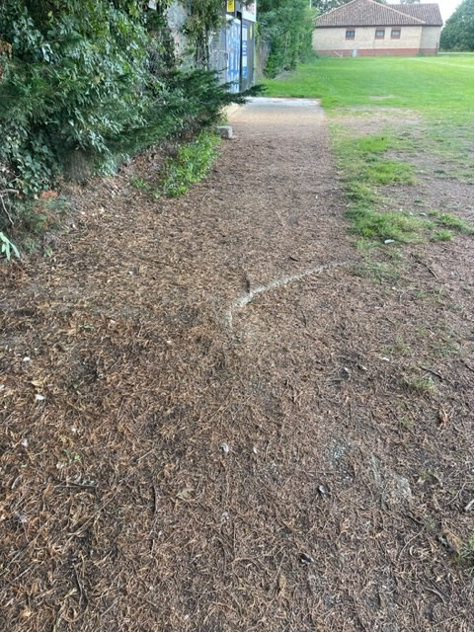

Members reviewed the outside of the Clubhouse and noted that the wooden struts on the veranda were rotten. TC suggested digging out around the wooden supports and building a brick pier and encase the posts in a steel sheet. ACTION TC to provide a quotation.
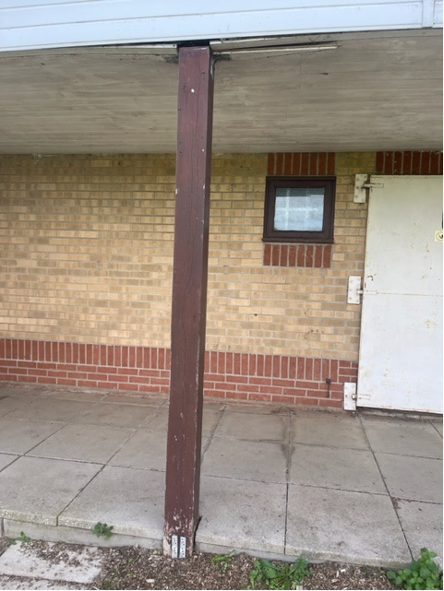

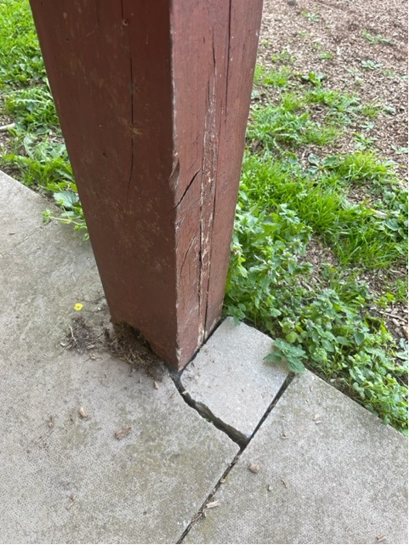
The Council Manager asked if the defibrillator had been registered on The Circuit yet. ACTION TC to check with the Committee member responsible.

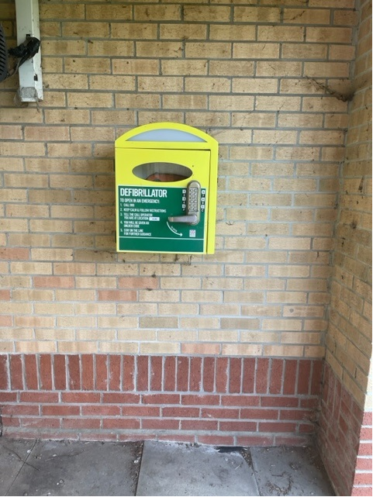

The Club asked if they could be given permission to brick up the unused door (below) to the cellar.
ACTION PC to consider request and respond.

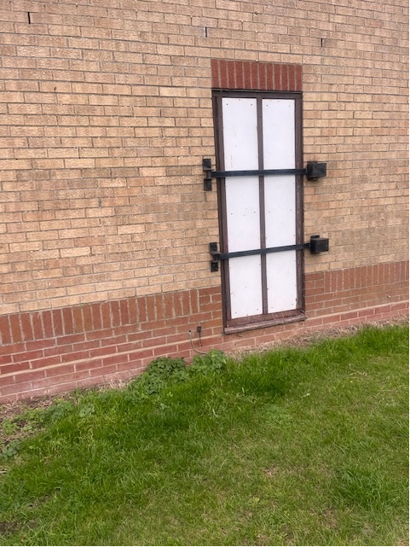
TC highlighted that the building had no disabed access and that the side entrance to the toilets (below) provided the best option to widen the door and install a ramp. ACTION TC to provide a quotation.

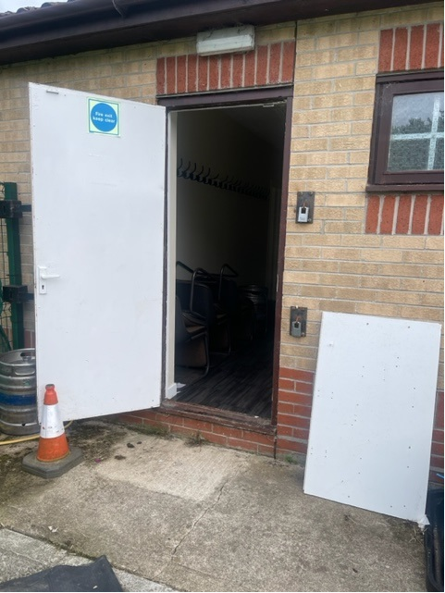

The fire exit door below is rotten and needs replacing.

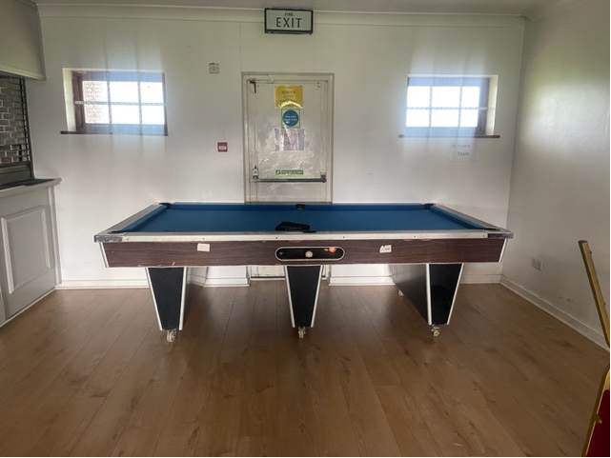

TC advised that the push bars on 2 fire exit doors are broken and 3 others do not have push bars fitted. ACTION TC to speak to the Club’s fire alarm service contractor, Protect and Detect, and instruct them to carry out an urgent Fire Risk Assessment on the whole building.

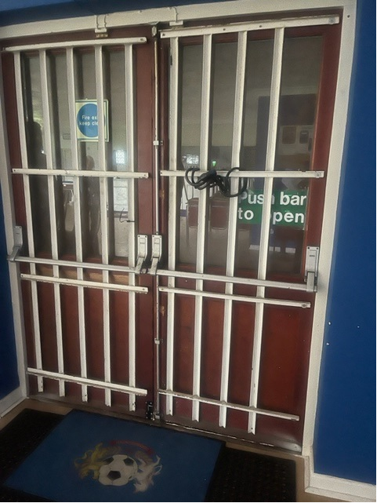
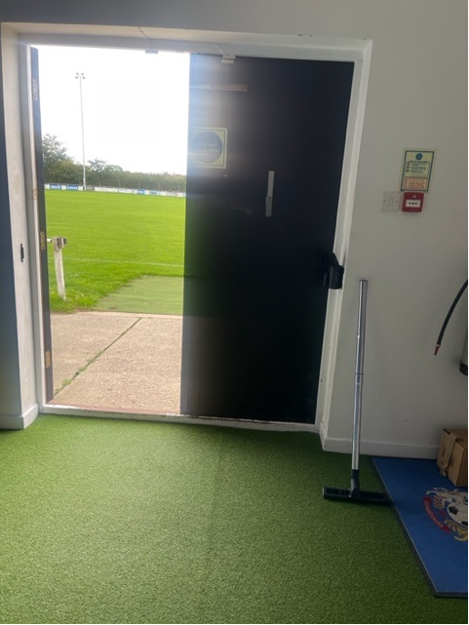

Members reviewed the area around the football pitch and agreed to ask the Community Wardens to enter the Council’s container and check that the Bromag mower was still operational. They would also be asked to search for the access to the sceptic tank as there was a foul odour in the area.

TC advised that it was the Club’s intention to reduce the height of the conifers to the left of entrance (below) and would eventually like to install wire meld fencing around the whole site.

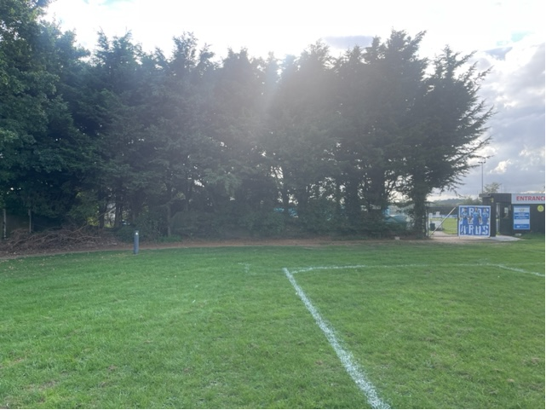

APPENDIX C

Section 59 Signage at the Allotment Car Park, Country Park Car Park and Shawlands Wood LNR

At a meeting of the Art, Sports and Leisure Committee on the 16th June 2023, Members agreed for the Council Manager to obtain costings for new Section 59 Police warning signs; two at each of the three locations. Suffolk Police have agreed that Parish Council can use their logo and requested that the word WARNING is added to the sign.

Auto Innovations have provided a quotation for these signs which is as follows:-

Allotment Car Park
2 x small signs to be fixed onto existing posts already showing the Parish Council Disclaimer Signs

Country Park Car Park
1 x large sign fixed to the wall
1 x large sign mounted on new post (also provided by Auto Innovations)

Shawlands Wood LNR
1 x large sign to be fixed to existing wooden fence
1 x small sign to be fixed to existing post already showing the Nature Reserve sign

The quotation is for:-

Item Cost exc. VAT

Set up (per hour, estimated at 1 hour) £ 25.00
3 x large di-bond signs printed laminated @410mm 510mm
@ £35 each £105.00
Additional charge for x1 railed (for round post) £ 10.00
3 x small di-bond signs printed laminated @410mm 300mm all
railed for posts @ £36 each £108.00
1 x grey 2400mm x 76mm post with fixings and cap @ £94 £ 94.00
Total exc VAT £342.00
Total inc VAT £410.40

Signs are to be made from aluminium composite which is water/weather proof and very durable. If the Council were to choose a full solid aluminium then there would be an additional cost of approximately £40 per sign (plus VAT).

Recommendation: that the Parish Council accepts the quotation from Auto Innovations for £342.00 plus VAT to supply 3 x large and 3 x small di-bond s.59 signs (aluminium composite) together with fixings and 1 x new post. Funds to come from the Recreation Budget.

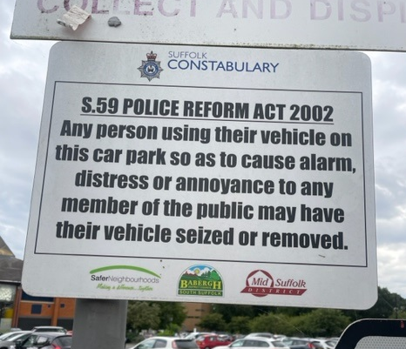
Add ‘WARNING’ at the top and move the Suffolk Constabulary logo to the bottom of the sign

Suffolk Constabulary and GCPC logo to be added at the bottom of the sign

APPENDIX D
Horses in the Country Park

At the meeting of the Art, Sports & Leisure Committee on the 24th July 2023, Members agreed that horses should be restricted to a walking pace in the Country Park, following correspondence received from a local resident. It was also agreed for the Council Manager to obtain a quotation to change the dangerous dogs signs already located at the Country Park gate by the Allotments and Blackhouse Lane entrances.

Auto Innovations were asked to provide a quote to add the words “Horses are restricted to walking pace only” to the existing signs.

The quotation provided is as follows:-

Item Cost exc VAT

Set up £ 15.00
Strip down and reuse/reprint existing dangerous dogs
signs with additional wording (shown below) £156.00
Total exc VAT £171.00
Total inc VAT £205.20

Recommendation: that the quotation from Auto Innovations for £171.00 plus VAT to strip down and re-do the dangerous dogs signs to include the wording above be accepted.
Funds to come from the Recreation Ground Budget.
GREAT CORNARD COUNTRY PARK
This Country Park is owned by Great Cornard Parish Council and managed, on its behalf, by Sudbury Common Lands Charity

Please keep your dogs under control at all times
(Dangerous Dogs Act 1991 Section 3)

Horses are restricted to walking pace only

www.greatcornard.onesuffolk.net
Telephone No: 01787 373212

Add this sentence to the existing signs

