GREAT CORNARD PARISH COUNCIL
Minutes of the Meeting of the ART, SPORT & LEISURE COMMITTEE
held in The Stevenson Centre at 7:16pm on Monday 24th April 2023

Present: Councillors M D Newman Chair
Mrs C J Baker Mrs M Bark
A C Bavington T J Keane
S M Sheridan C G Wright D Young

Council Manager Mrs N Tamlyn
Council Administrator Miss E Skuce

- APOLOGIES FOR ABSENCE

Apologies were received from Councillors Mrs J Wilson and Mrs T E A Welsh.

The Chairman thanked Members for their support and hard work over this current term and stated that the Committee had achieved a lot for the benefit of Great Cornard residents. The Chair also thanked the Council Manager and staff for their hard work.

2. DECLARATIONS OF INTEREST AND REQUESTS FOR DISPENSATIONS

Councillor Bavington declared a non-pecuniary interest in any matter relating to Thomas Gainsborough School as he volunteers at the school and a family member is employed by the Trust.

Councillor Young declared a non-pecuniary interest in any matter relating to Thomas Gainsborough School as he and a family member are employed by the Trust.

3. DECLARATIONS OF GIFTS AND HOSPITALITY

NONE.

4. ITEMS BROUGHT FORWARD – FOR NOTING

Members reviewed and NOTED the Items Brought Forward List.

5. TO RECEIVE A FINAL REPORT ON KNOTWEED AT THE ALLOTMENTS

Members NOTED Report No. F17 (see Appendix A) which states that all treatment for Knotweed at the Allotments had now been completed and that an Invasive Weed Guarantee, valid for a period of 10 years, had been received from the contractors dealing with it. The Council Manager confirmed that the new growth recently discovered had been identified as Cuckoo Pint Plant. It was AGREED to remove this item from the Brought Forward List.

6. TO RECEIVE AN UPDATE ON THE INSTALLATION OF A YELLOW LINE AND TWO DISCLAIMER SIGNS AT THE ALLOTMENT CAR PARK

Members reviewed and NOTED photographs of the new yellow boundary line and two disclaimer signs at the Allotment car park (see Appendix B). Members stated that they were happy with both the line and the signs and it was AGREED to remove the item from the Brought Forward List.

7. TO RECEIVE AN UPDATE ON THE REPLACEMENT FENCE AT SHAWLANDS LOCAL NATURE RESERVE

Members reviewed photographs of the replacement fence which had been completed by Sudbury Common Lands Charity and their team of volunteers (see Appendix C). Members were happy with the fence and the Council Manager explained that once the new vehicle and pedestrian entrance had been completed, the gap in this section of fence would be closed. NOTED. It was AGREED to remove this item from the Brought Forward List.

8. TO RECEIVE AN UPDATE ON THE SECTION 106 GRANT FOR THE PLAY AREA TENDER

The Council Manager explained that the Parish Council’s application for Section 106 funding for the new play equipment Tender had been submitted to Babergh District Council, for the previously available sum of £51,901.76. However, the District Council have since advised that funds of £57,621.71 are now available to apply for; an increase of £5,719.95.

Members AGREED to apply for the full amount of £57,621.71 and reduce the Parish Council’s contribution towards the project. The remaining sum of £5,719.95 would be considered as part of the Council’s virement in July 2023.

9. TO CONSIDER A QUOTATION FOR A NEW WASHROOM BIN IN THE EXTERNAL TOILETS AT BLACKHOUSE LANE PAVILION

Members considered a quotation from Command Pest Control for £100.00 plus VAT per annum to supply and service a 23lt sanitary bin every four weeks at the Blackhouse Lane Pavilion external toilets.

Members AGREED to accept the quotation from Command Pest Control for £100.00 plus VAT per annum, to supply and service a 23lt sanitary bin every four weeks at the Blackhouse Lane Pavilion external toilets.

Funds to be allocated from the Blackhouse Lane Budget.

Meeting closed at 7:23pm

APPENDIX A
Report No. F17
Knotweed Report
In January 2023, James Blake Associates Ltd, the Council’s Japanese Knotweed contractor, carried out the final site visit and confirmed that all the treatments are now complete and the fencing was removed from the area. The Parish Council subsequently received the Invasive Weed Guarantee which is valid for 10 years. As part of the guarantee, the contractor will continue to monitor the site over the next 2 years and beyond if needed.
Following a site visit by Council staff, two new plants were found on the allotment where the knotweed had previously been identified. The matter was immediately brought to the attention of the contractor and following a site visit by their Weed Eradication Specialist, they’ve confirmed that neither plant is Japanese Knotweed.
As a precautionary measure, the decision was taken not to let the allotment this year and the Council’s staff will continue to monitor and manage the area accordingly.

Council Manager 17th April 2023

APPENDIX B
Update on the resurfaced car park at the Allotments
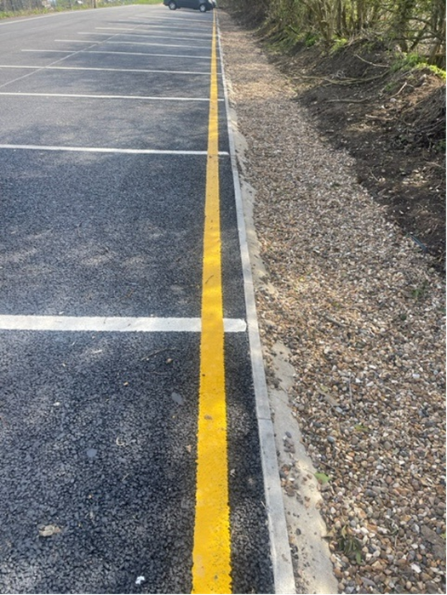
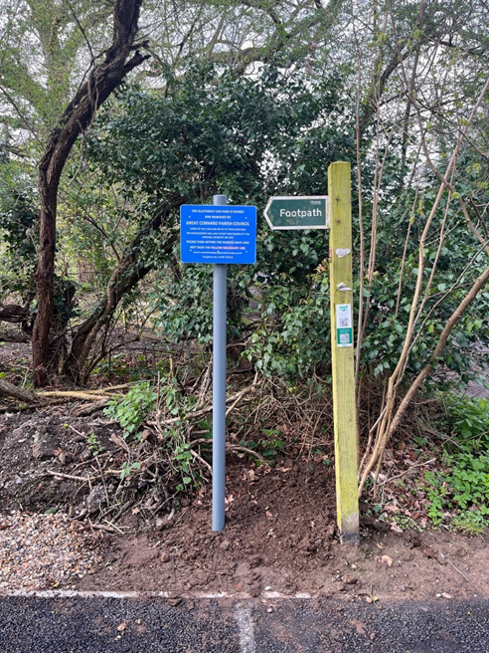
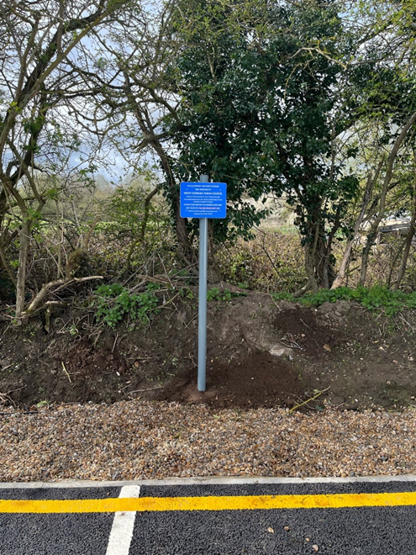

APPENDIX C
Update on the new fencing at Shawlands LNR

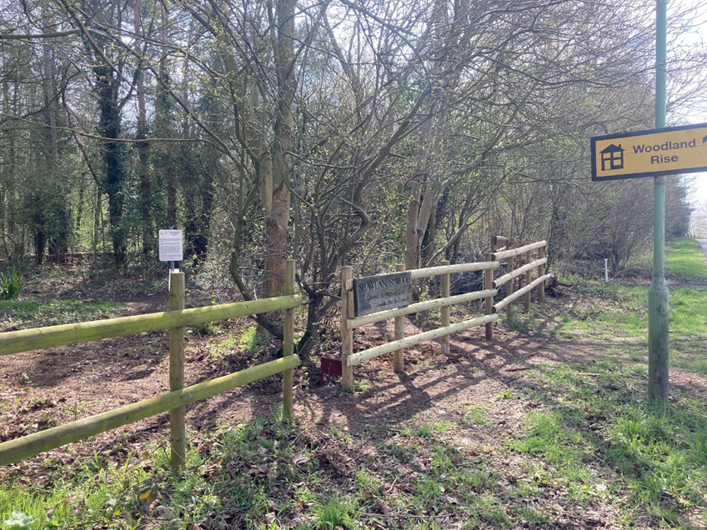
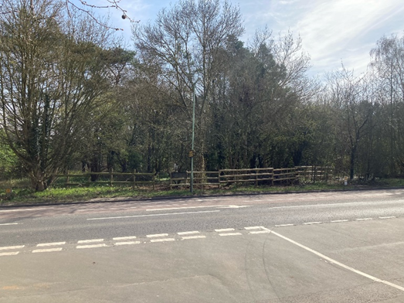
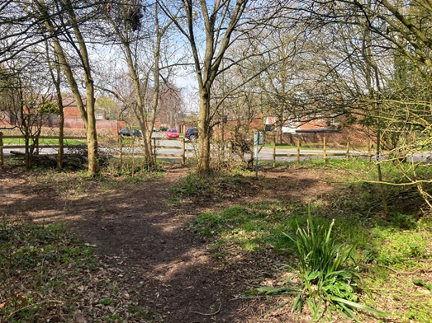

Photos of completed fence and reinstalled Shawlands LNR sign, which were all damaged in the collision reported to the Parish Council on 7th November 2022.

